**Online Bus Ticket Booking Application**

**Introduction**

This project is a **Bus Ticket Booking Application** designed to provide a seamless experience for users to register, search for buses, book tickets, and generate PDF confirmations. The application supports two roles:

1. **User:** Can search for buses, book tickets, and view their bookings.
2. **Admin:** Can manage bus details, including adding, updating, and deleting bus information.

Additionally, the application comes with an integrated frontend, the details of which can be accessed via the provided Drive link (ensure to read the **Mandatory Information**).

**Table of Contents**

1. **Features**
2. **Technologies Used**
3. **Running the Application**
   * Prerequisites
4. **Usage**
   * User Registration and Login
   * Admin Functionalities
   * Booking Tickets
5. **Mandatory Information**
6. **Frontend Details**

**Features**

* User registration and secure login with Spring Security.
* Role-based access control for **Admin** and **User**.
* Search for buses by **origin**, **destination**, and **date**.
* Book bus tickets with the ability to input passenger details.
* View and manage individual booking tickets.
* Generate **PDF confirmations** for bookings.
* Admin-specific functionalities for managing buses:
  + Add, update, delete bus details.

**Technologies Used**

1. **Backend:**
   * Java
   * Spring Boot (REST API development)
   * Spring Security (authentication and authorization)
   * Jakarta Servlet API
   * iTextPDF (PDF generation)
   * Lombok (boilerplate code reduction)
2. **Frontend:**
   * Details available in the provided Drive link.
3. **Database:**
   * Relational Database (e.g., MySQL or PostgreSQL)

**Running the Application**

**Prerequisites**

* **Java**: Version 17 or higher
* **Maven**: Version 3.6.3 or higher
* **Database**: A relational database (e.g., MySQL or PostgreSQL)

**Steps to Run the Application**

1. **Clone the repository**: Download the project files.
2. **Configure the database**:
   * Update the application.properties or application.yml file with your database credentials:

properties

CopyEdit

spring.datasource.url=jdbc:mysql://localhost:3306/bus_ticket_booking

spring.datasource.username=<your-database-username>

spring.datasource.password=<your-database-password>

spring.jpa.hibernate.ddl-auto=update

1. **Build the application**:
   * Run mvn clean install to build the project.
2. **Run the application**:
   * Execute java -jar <application-jar-file> or run the application directly from an IDE.
3. **Access the application**:
   * Open a web browser and navigate to http://localhost:8080.

**Usage**

**1. User Registration and Login**

* **Registration**:
  + Access /registration to create a new user account.
  + Input details like username, email, and password.
* **Login**:
  + Navigate to /login to log in using registered credentials.

**2. Admin Functionalities**

* Log in as an admin to access the admin dashboard.
* **Manage buses**:
  + **Add a new bus**: Navigate to /addBus.
  + **View all buses**: Use /viewAllBuses.
  + **Find a bus by ID**: Access /findBusById.
  + **Update bus details**: Update details via /updateByBus.
  + **Delete a bus**: Delete via /delete/{serialNo}.

**3. Booking Tickets**

* **Search for buses**:
  + Use the search functionality on the user home page to find buses by origin, destination, and travel date.
* **Book a bus**:
  + Navigate to /bookBus/{busId} to book tickets for a specific bus.
* **View bookings**:
  + Access all your bookings at /bookings.
* **Generate PDF confirmation**:
  + Generate a booking confirmation PDF at /generatePdf/{bookingId}.

**Mandatory Information**

* Ensure the application runs on a port other than **8080** if it's already in use. You can modify the port in application.properties:

properties

CopyEdit

server.port=<desired-port>

* Always verify that the database service is up and running before starting the application.

User Interface:

Home Page  
  
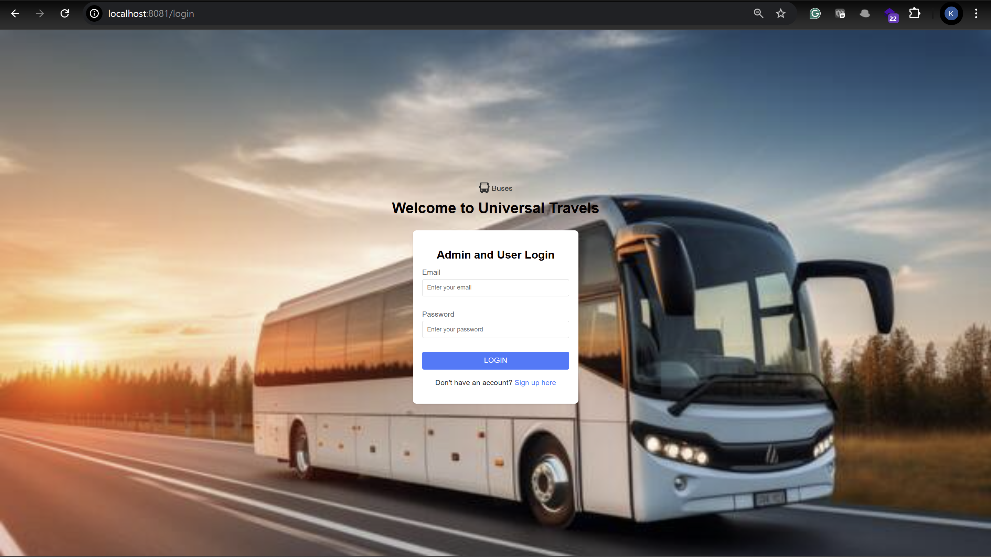

On the same page, we can log in with Admin and User Login.

As per the security concern, we have disabled the sign-up for admin users. In real time, the admin team needs to sign up with a norma user later by calling customer care; they can then change their role. Beginning, everyone comes under the USER role.

Sign-up page

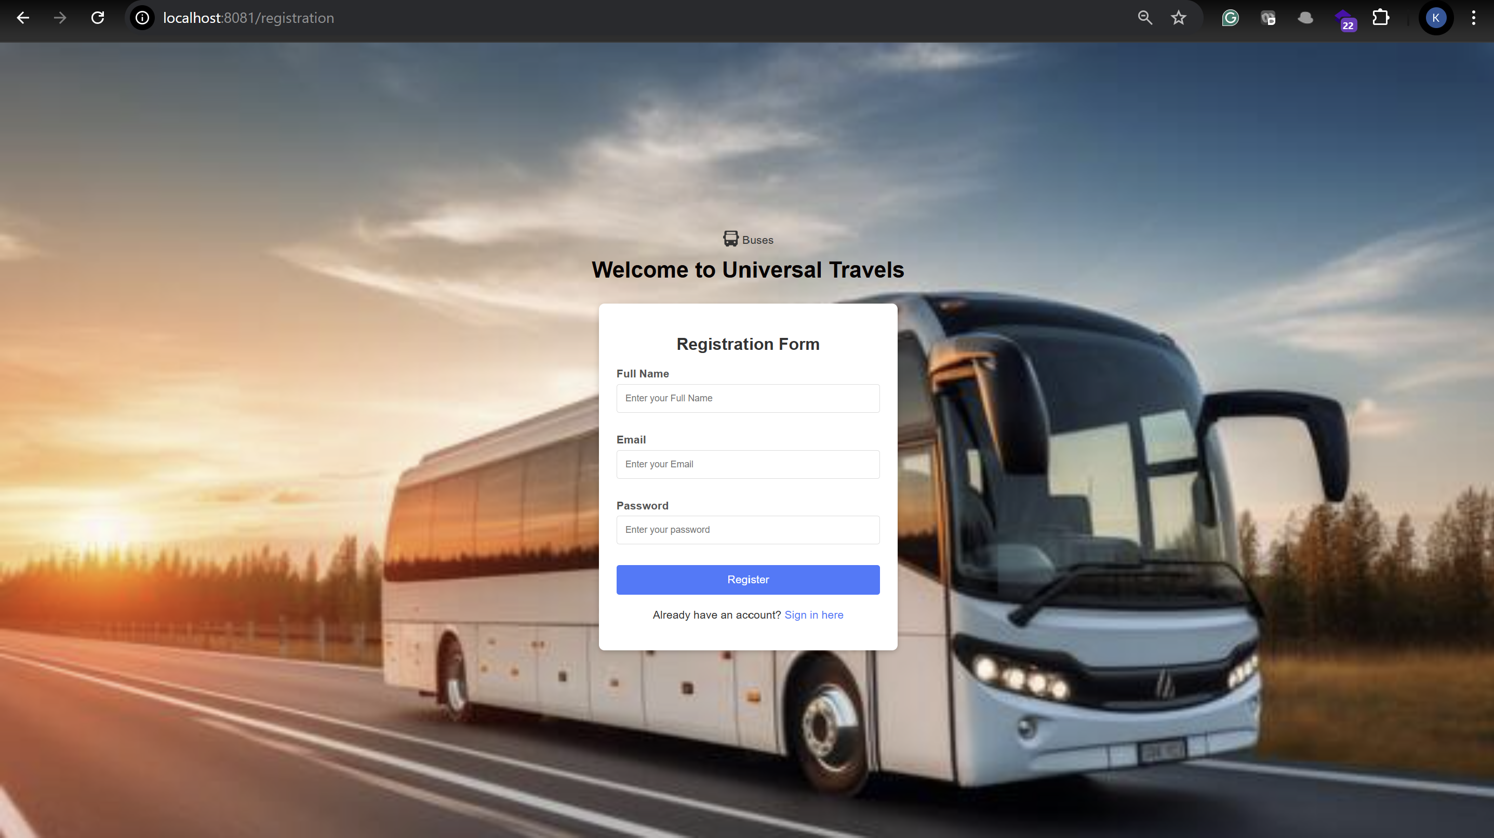

After registration you will get pop-up like below then click on sign in to log in  
  
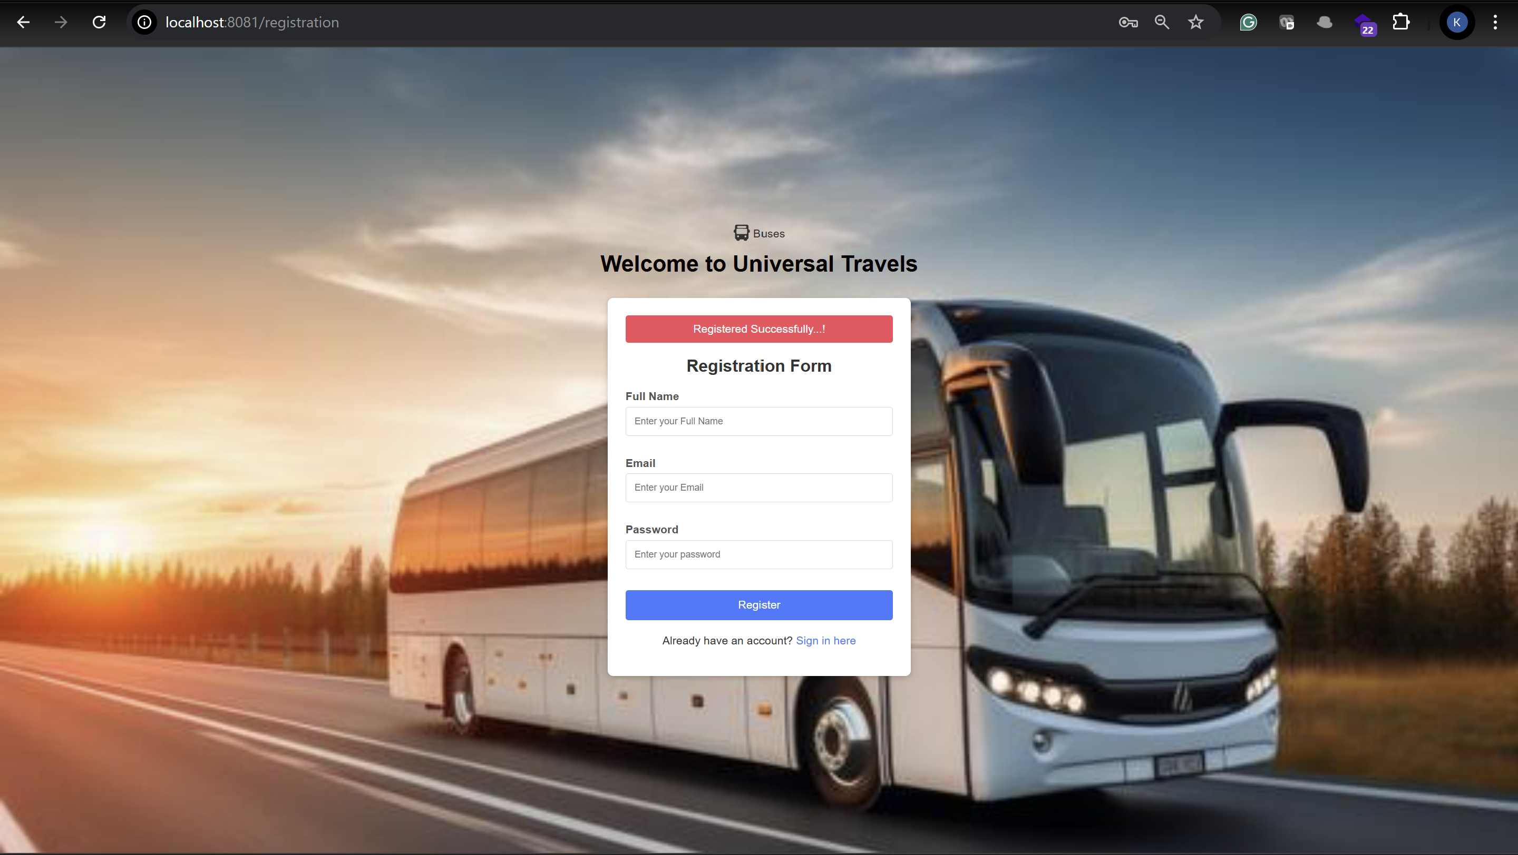

As I mentioned initially everyone has USER role so you will land on below page

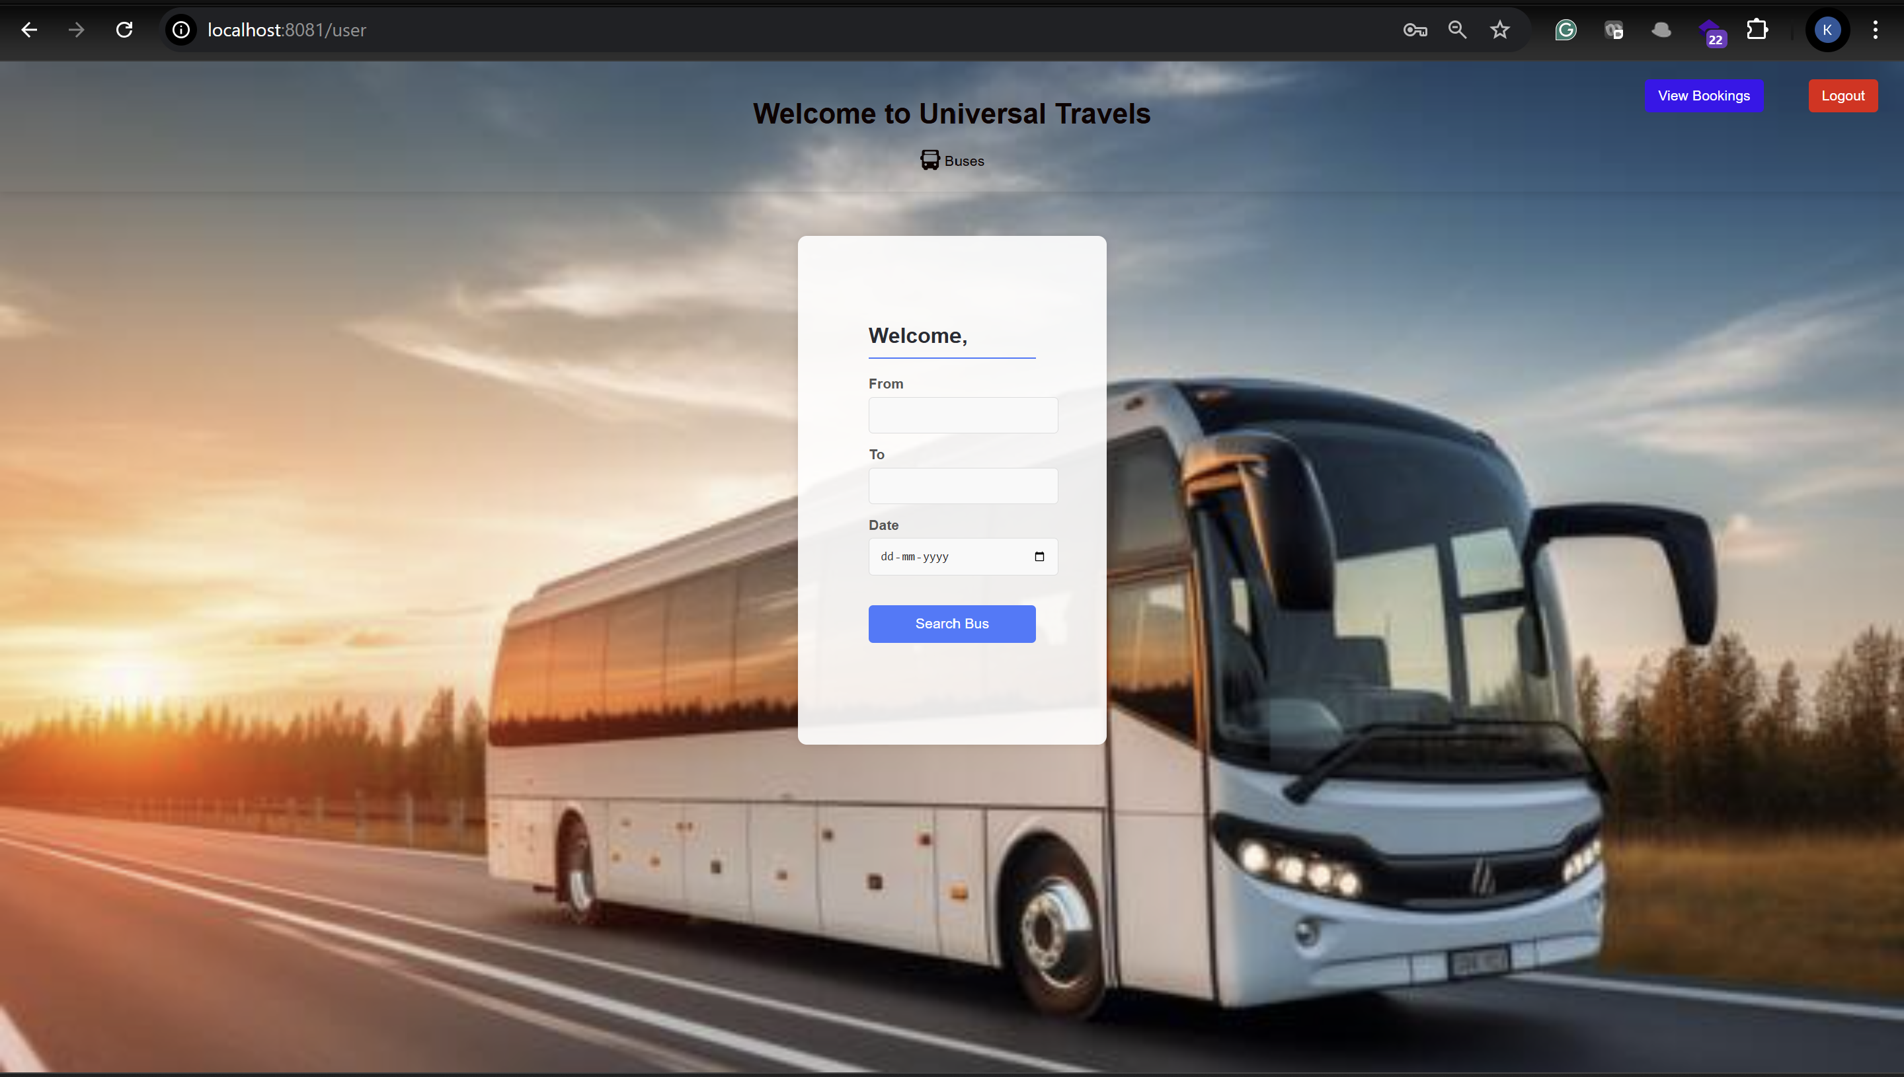

After Changing the role to ADMIN from Database Admin will land on below page

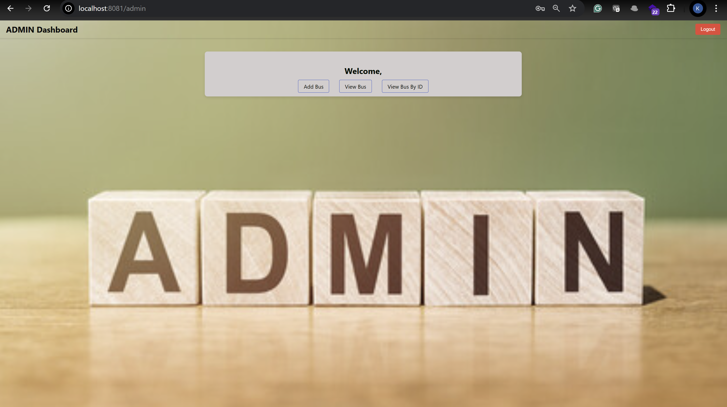

Here Admin will get option to Add View and Search the Bus.

**Add Bus:**

**User Interface to add bus**

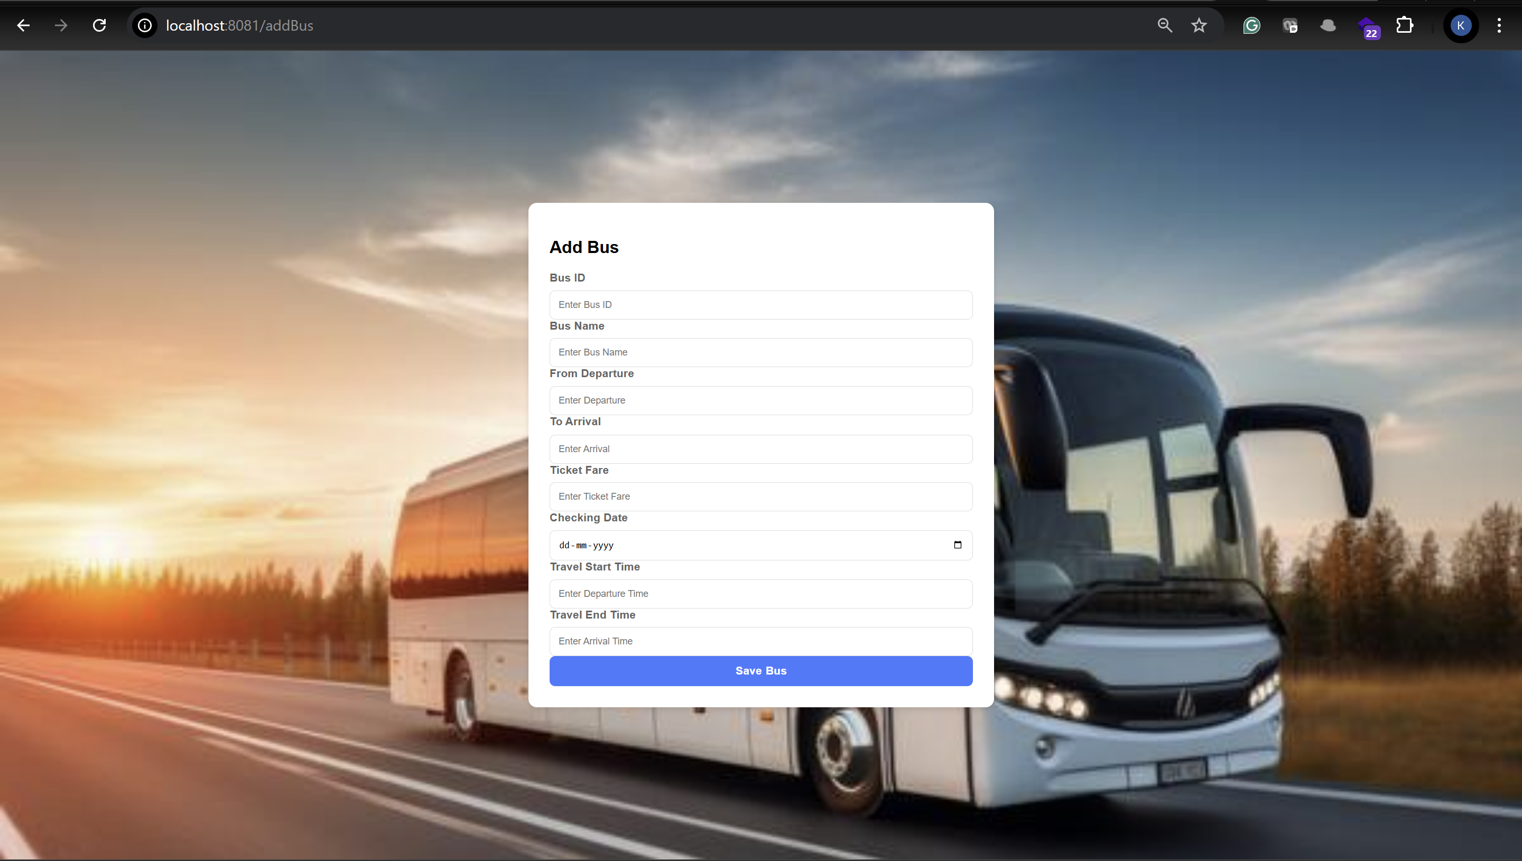

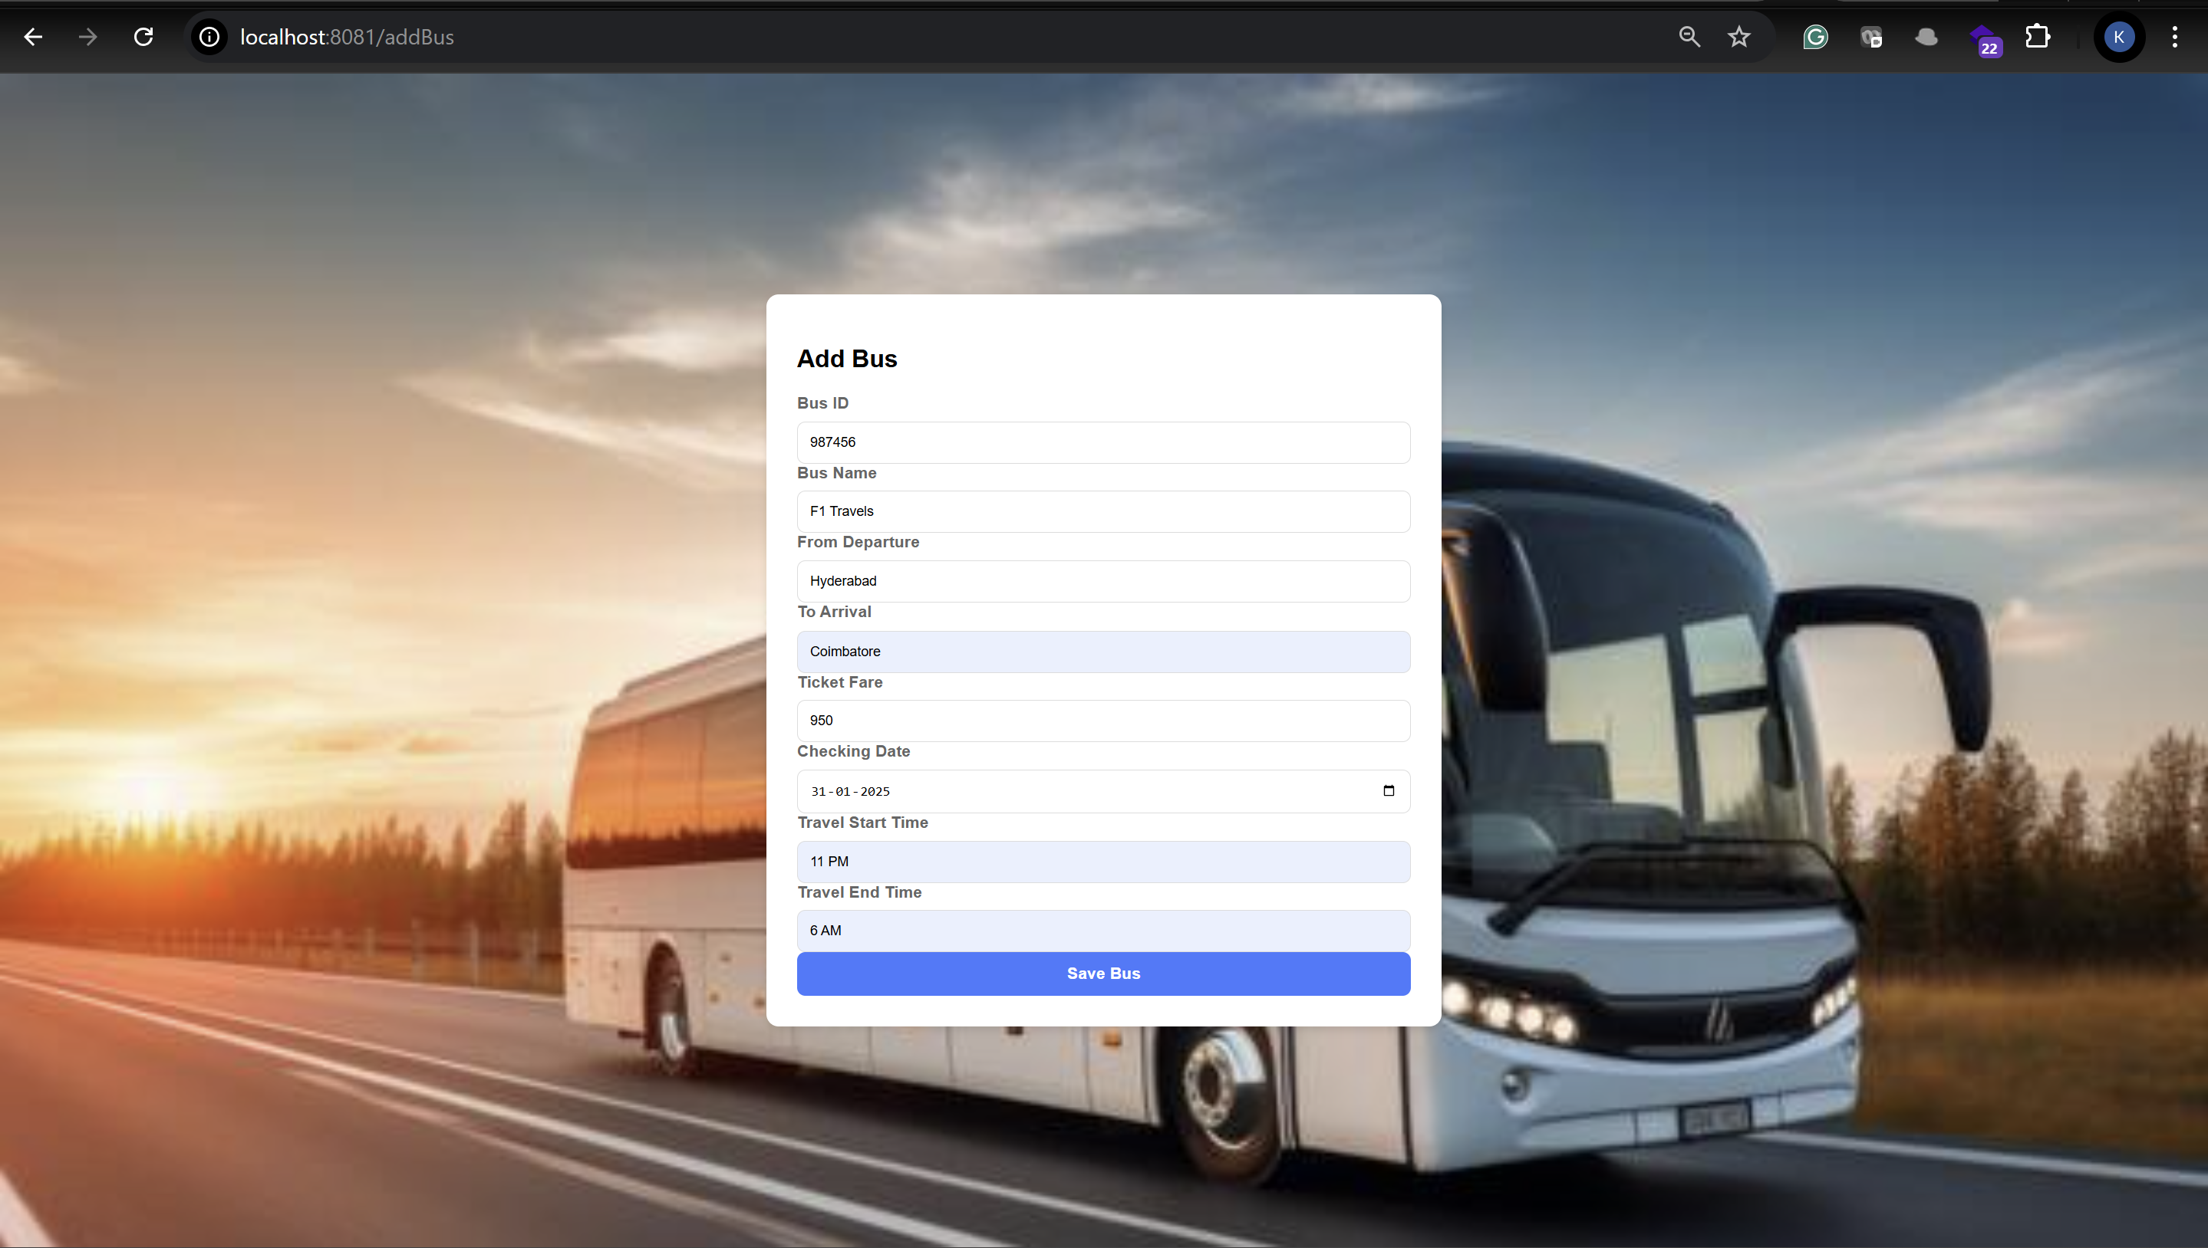

**Bus Details will be added to the db by clicking the save bus button.**

**By Clicking view bus Admin can access the list of buses  
  
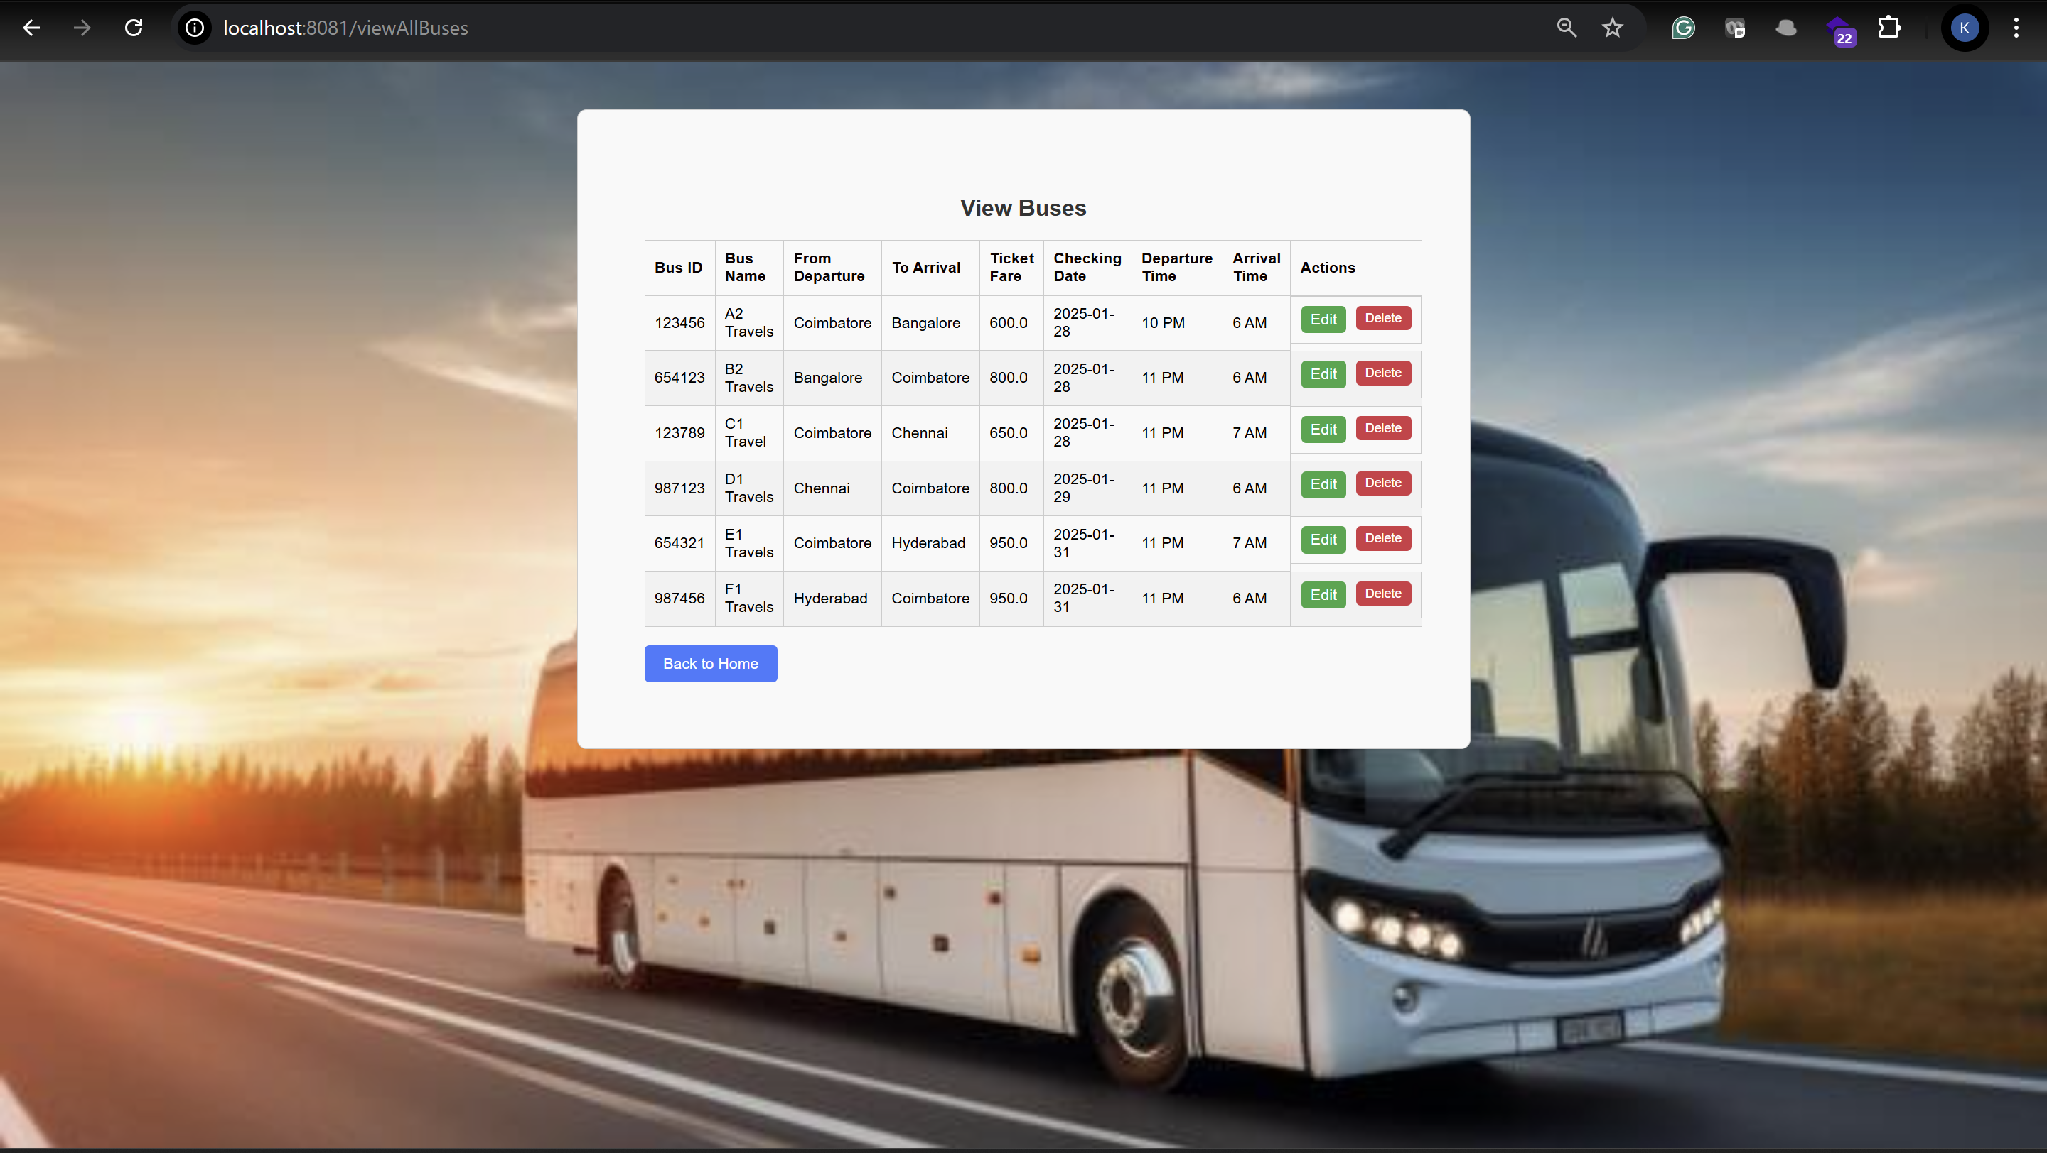**

**Search the bus by id  
  
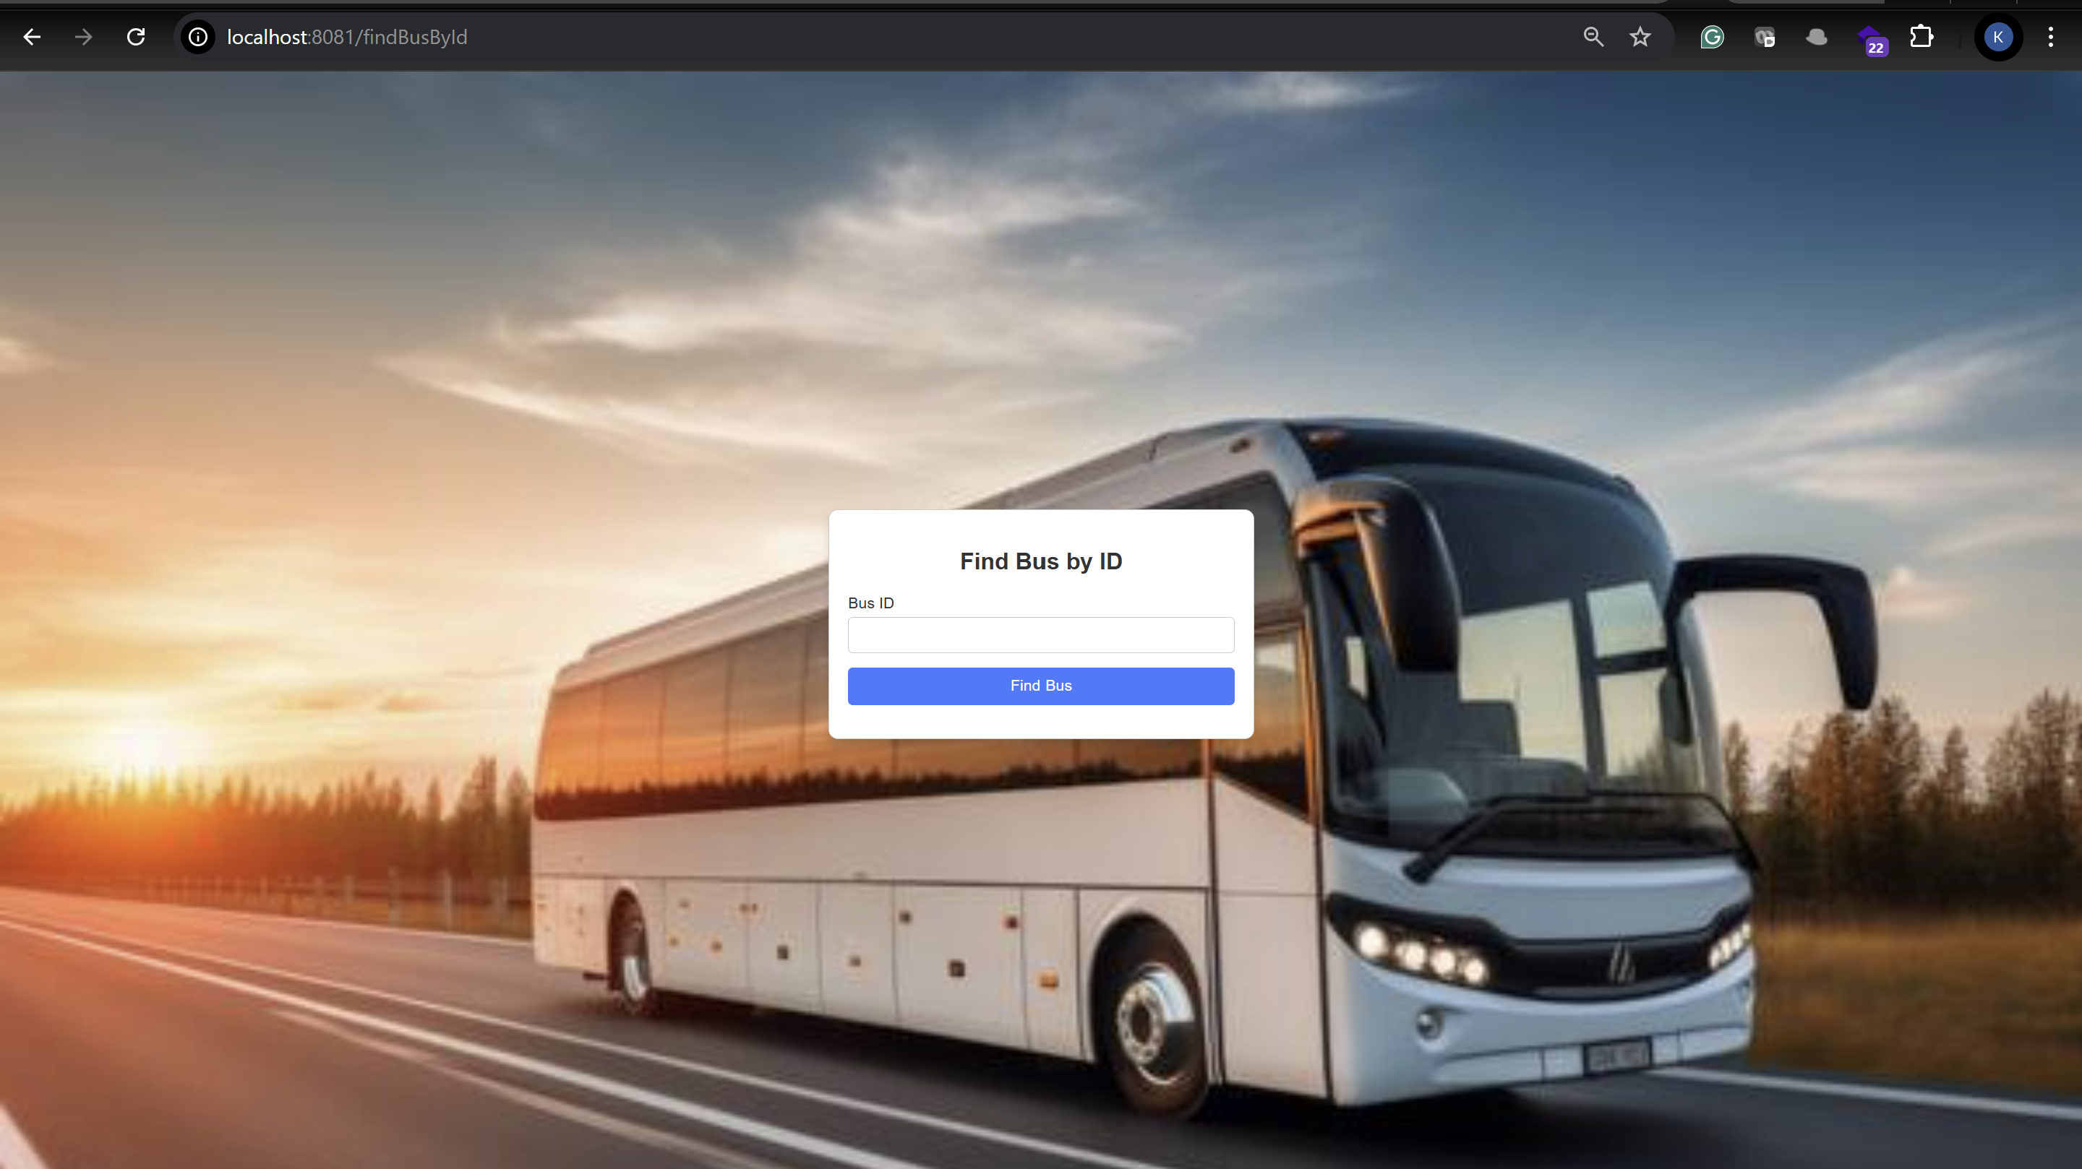**

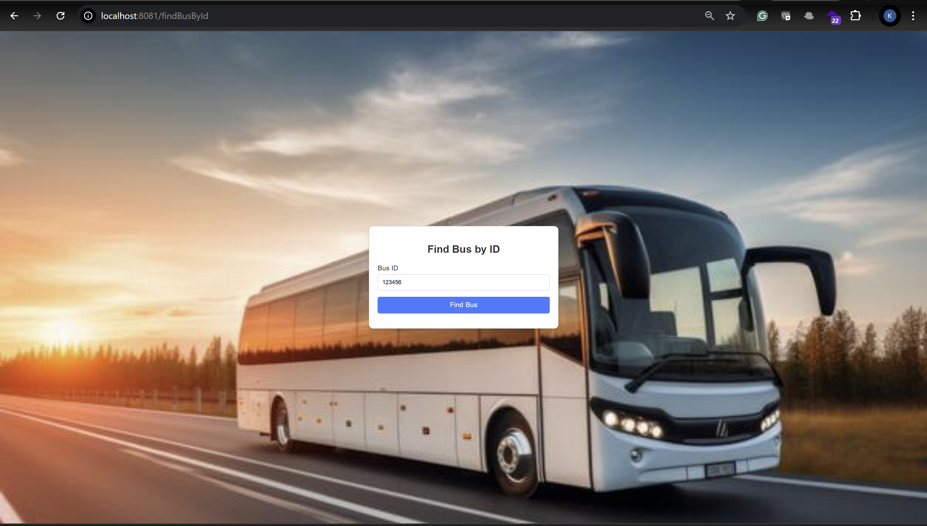

**By clicking find the bus you will see the bus details, where the admin can edit or delete the bus  
  
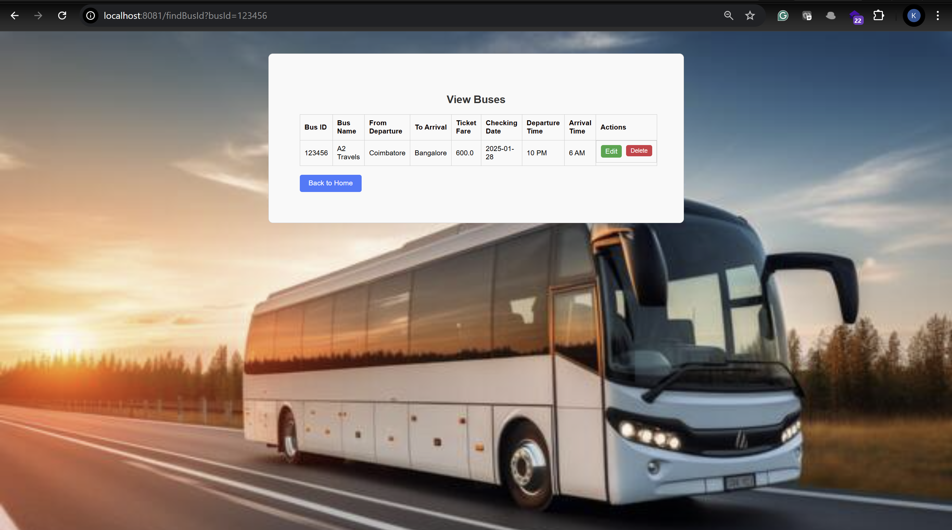**

**Once the admin click log-out from the top right page, they can logout successfully and redirected to below page  
  
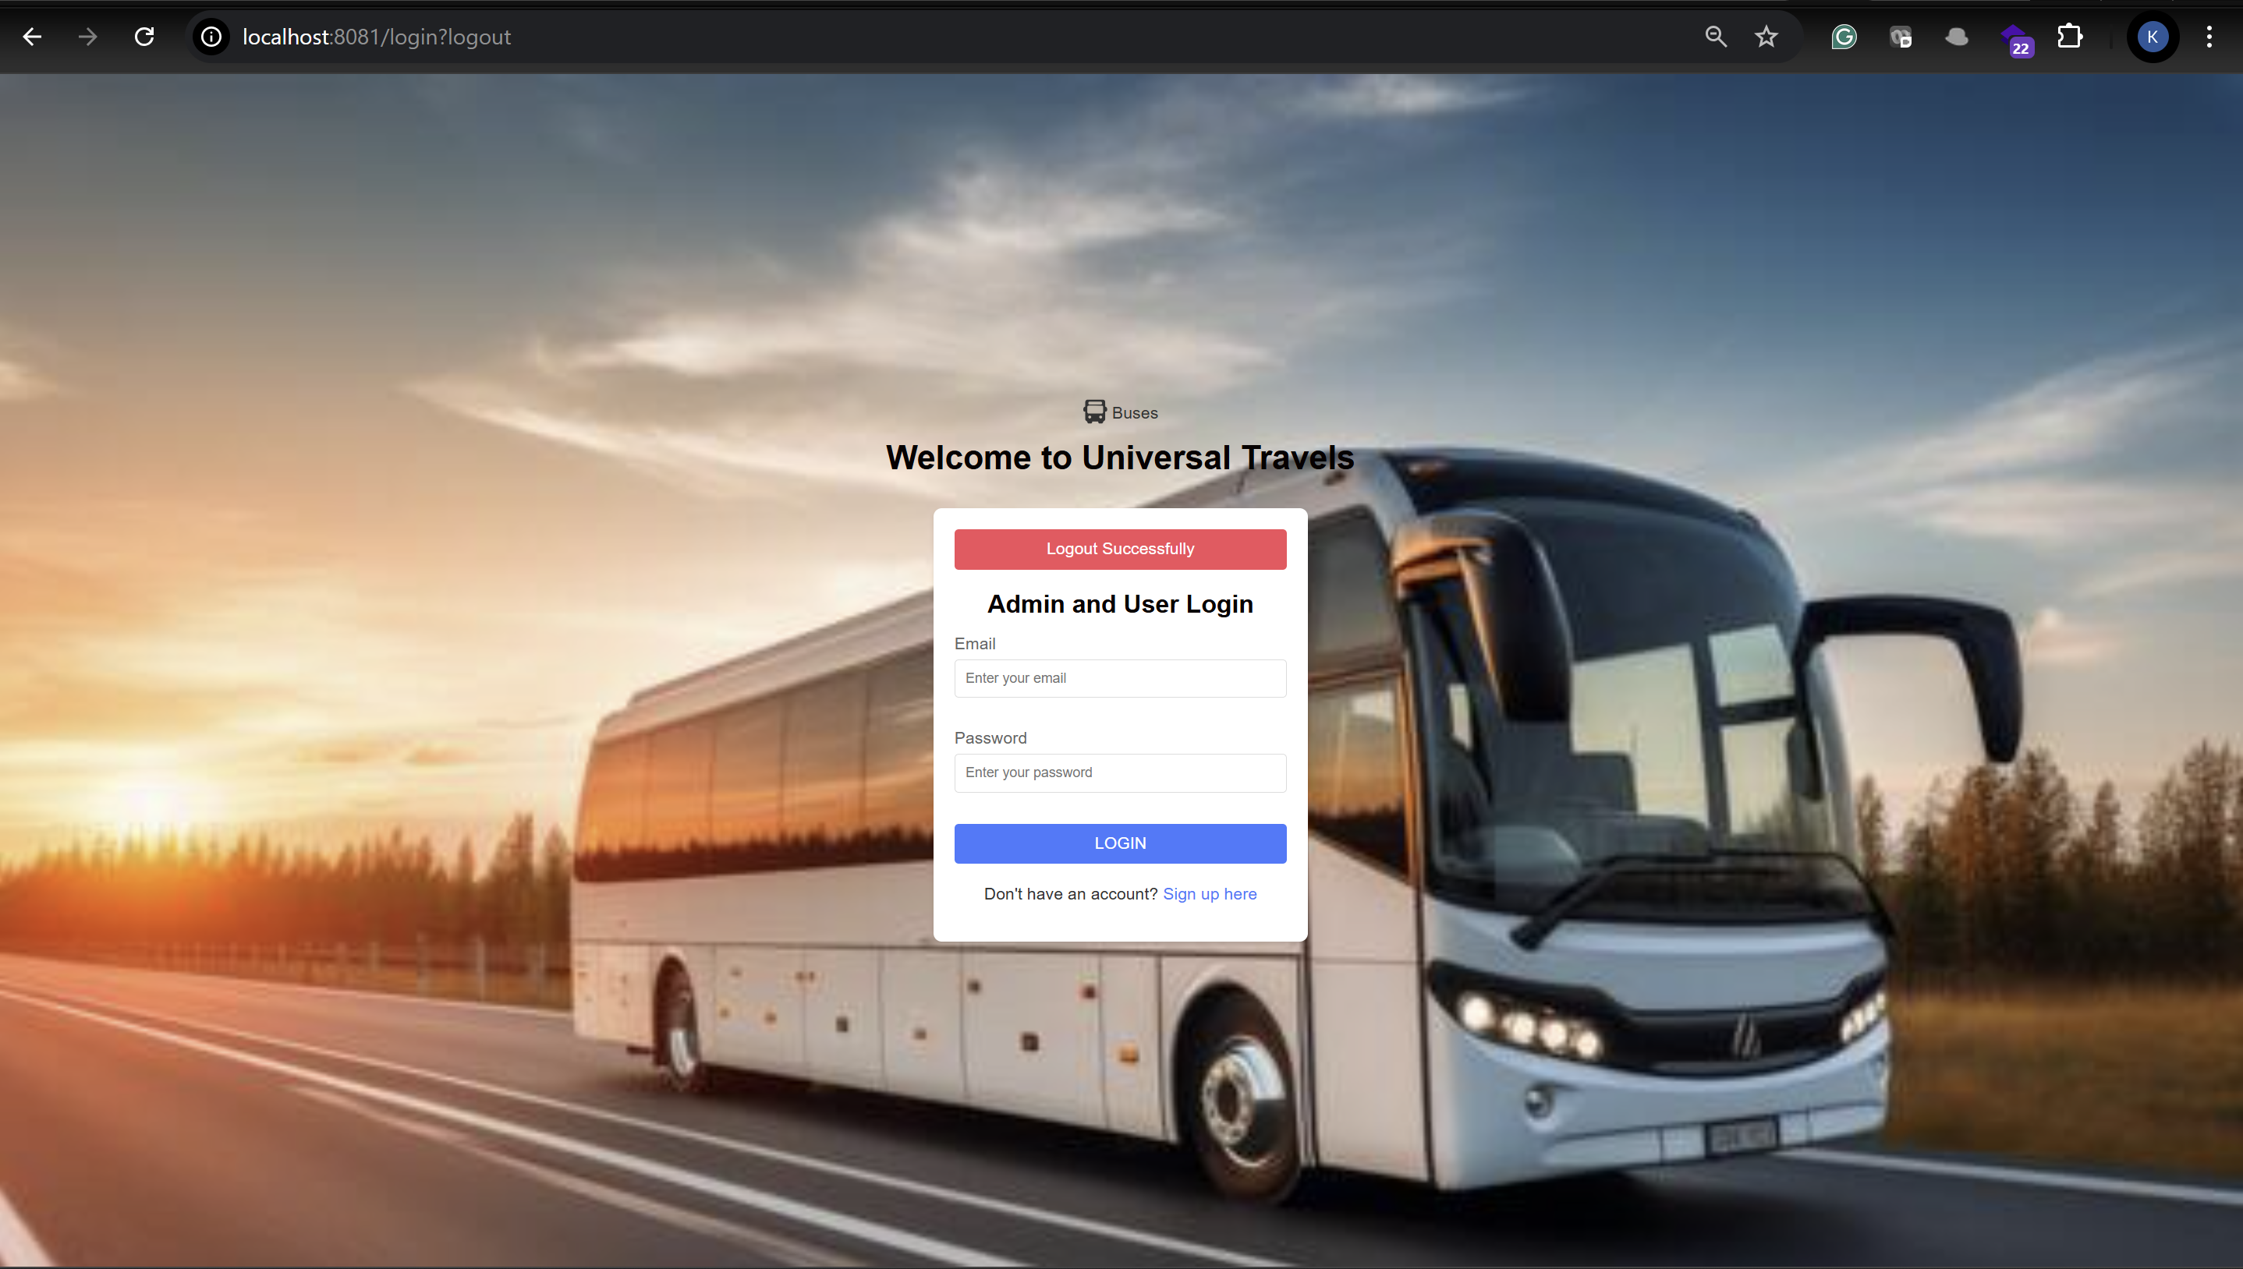**

**User sign-up and login**

Click on signup from home page

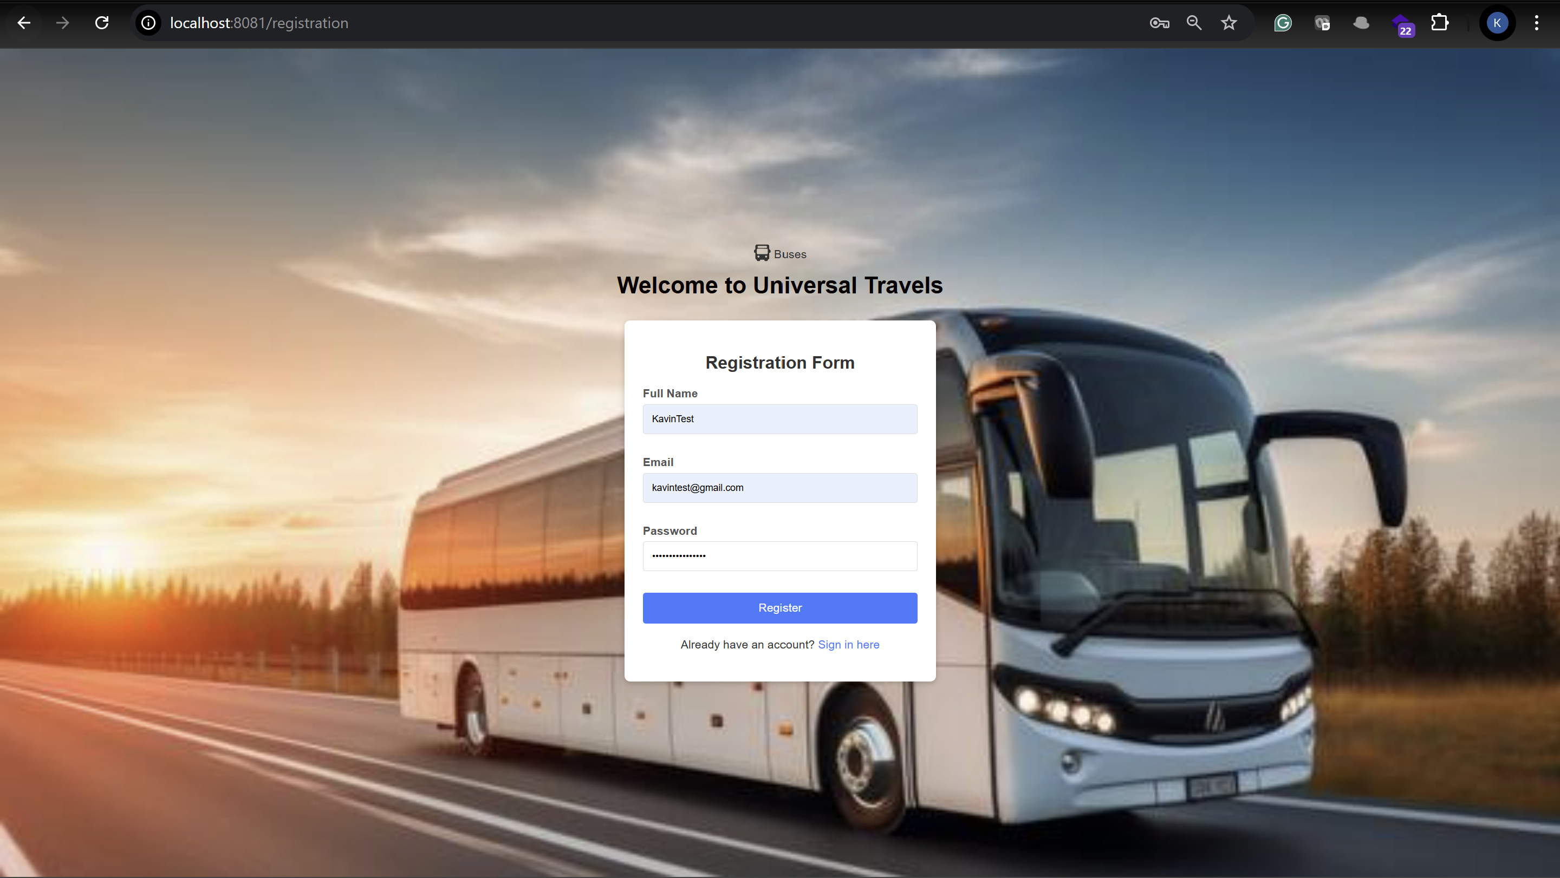

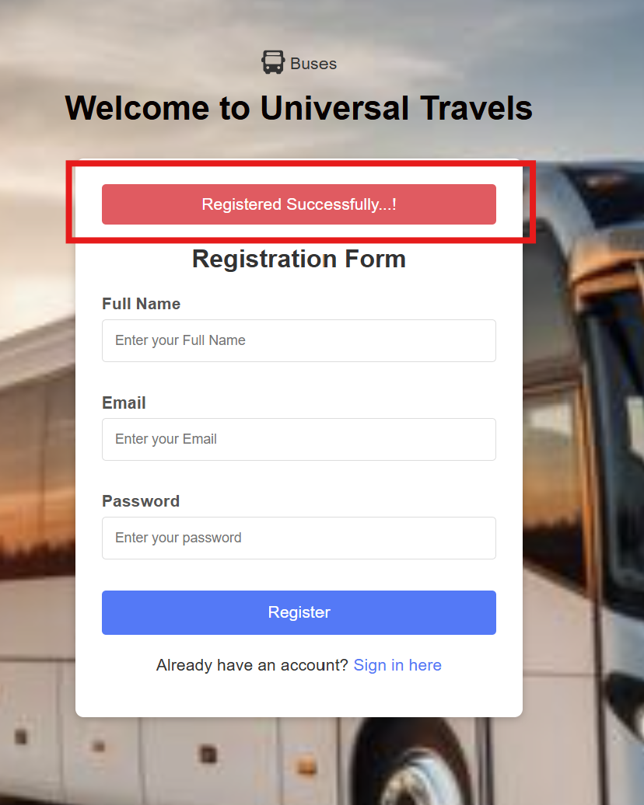

User Login page

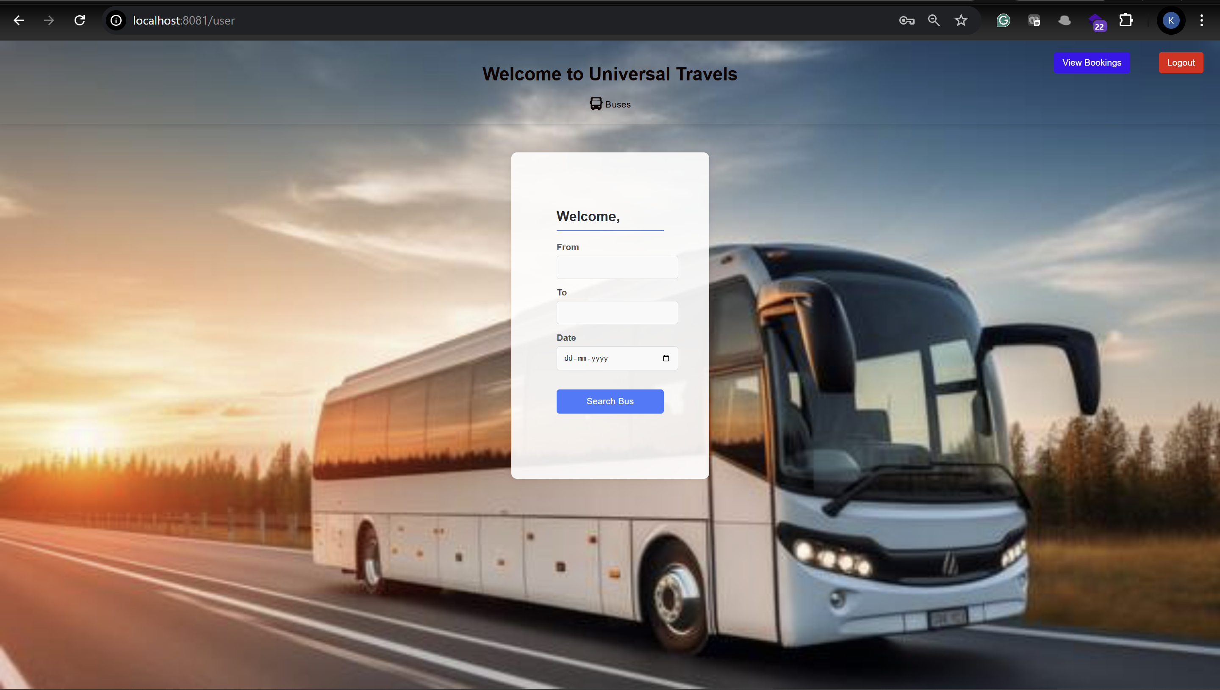

By selecting the required details user can view the list of bus  
  
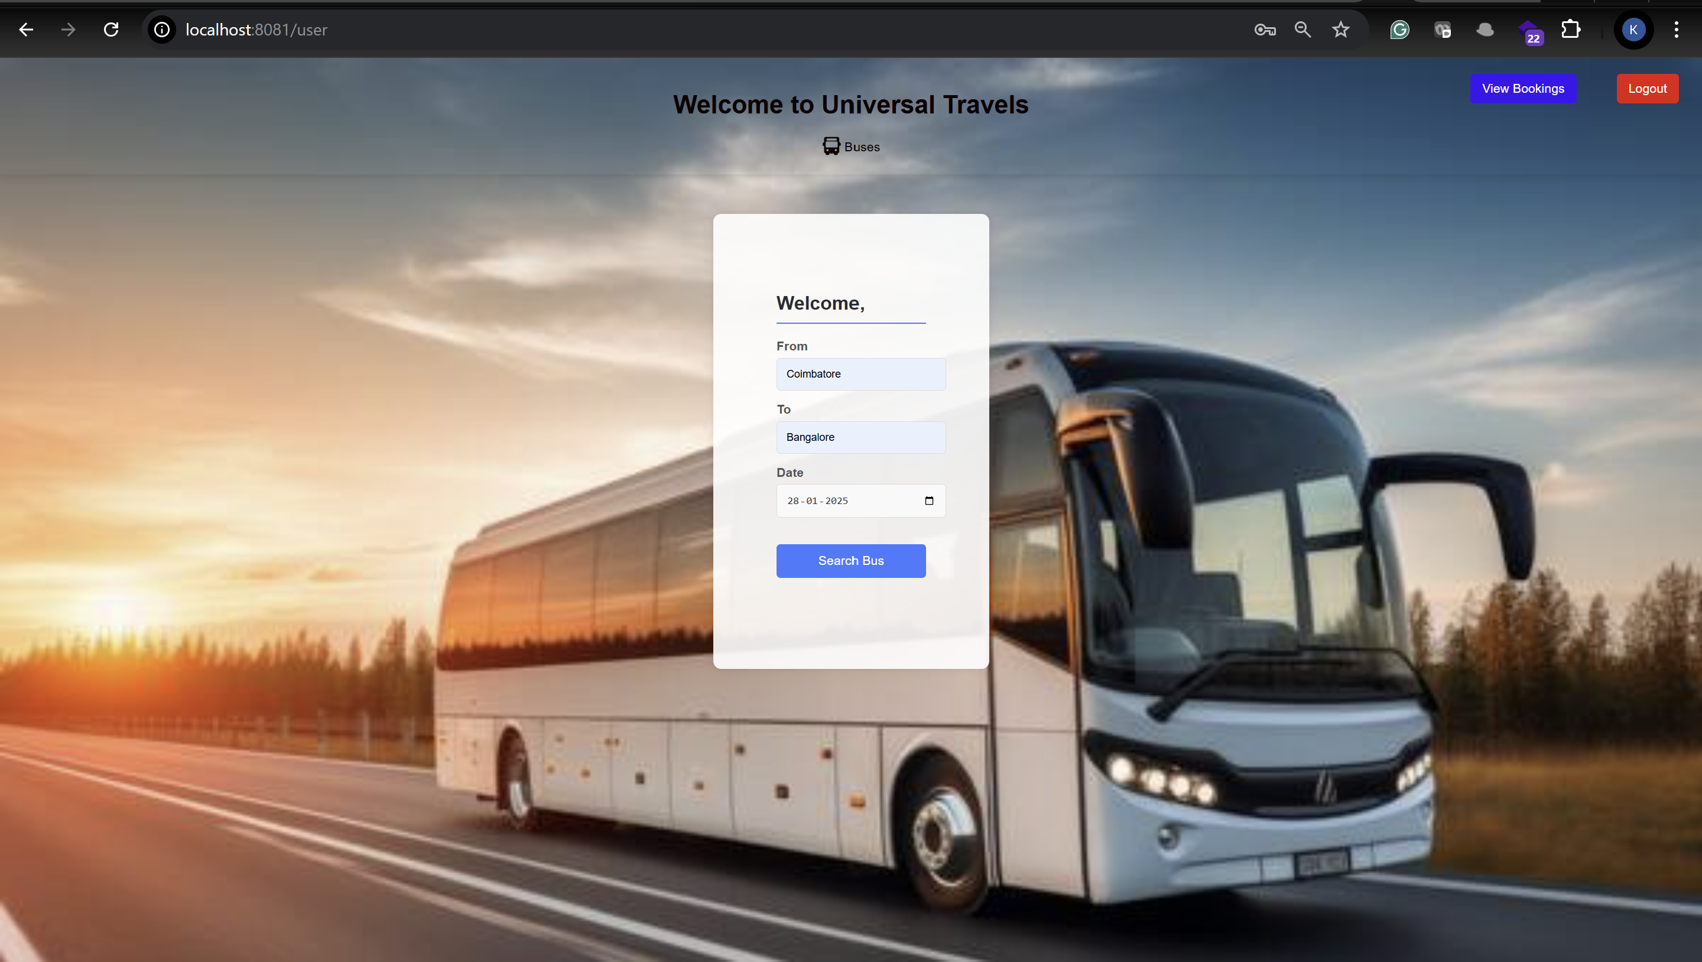

Result page  
  
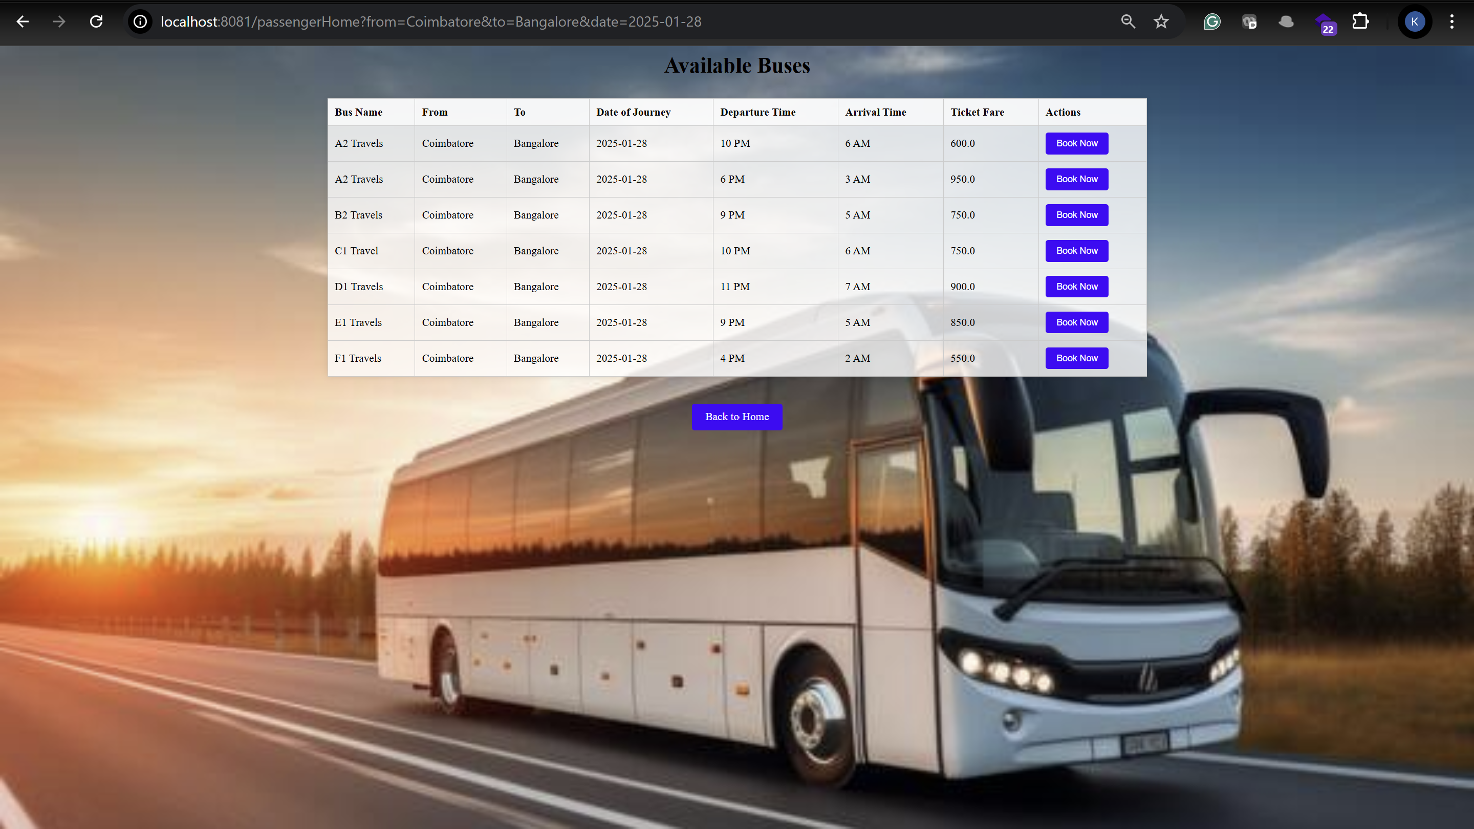

Here customer can choose a bus and book the ticket

By clicking the Book Now Button user will land on the below page where they can enter their details  
  
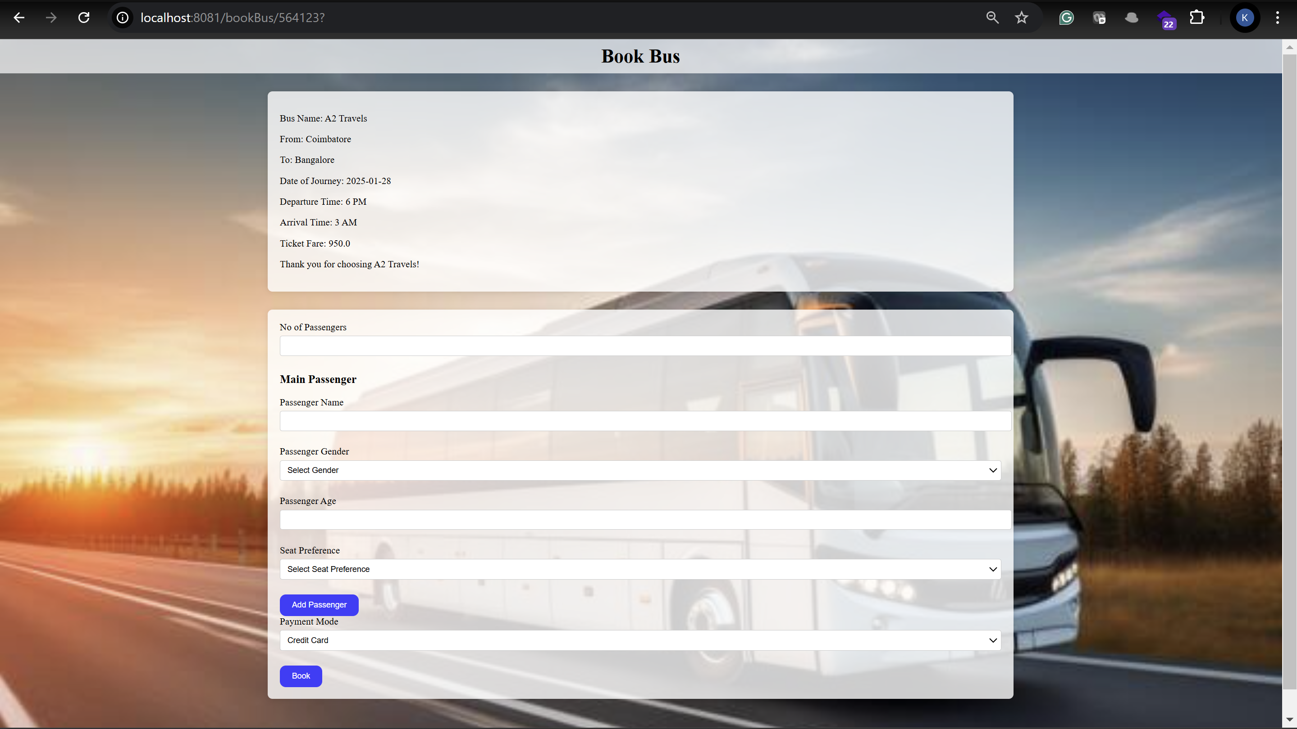

Once you enter the person 1 details you will be an option to add a passenger button to add as many person details as the user wants  
  
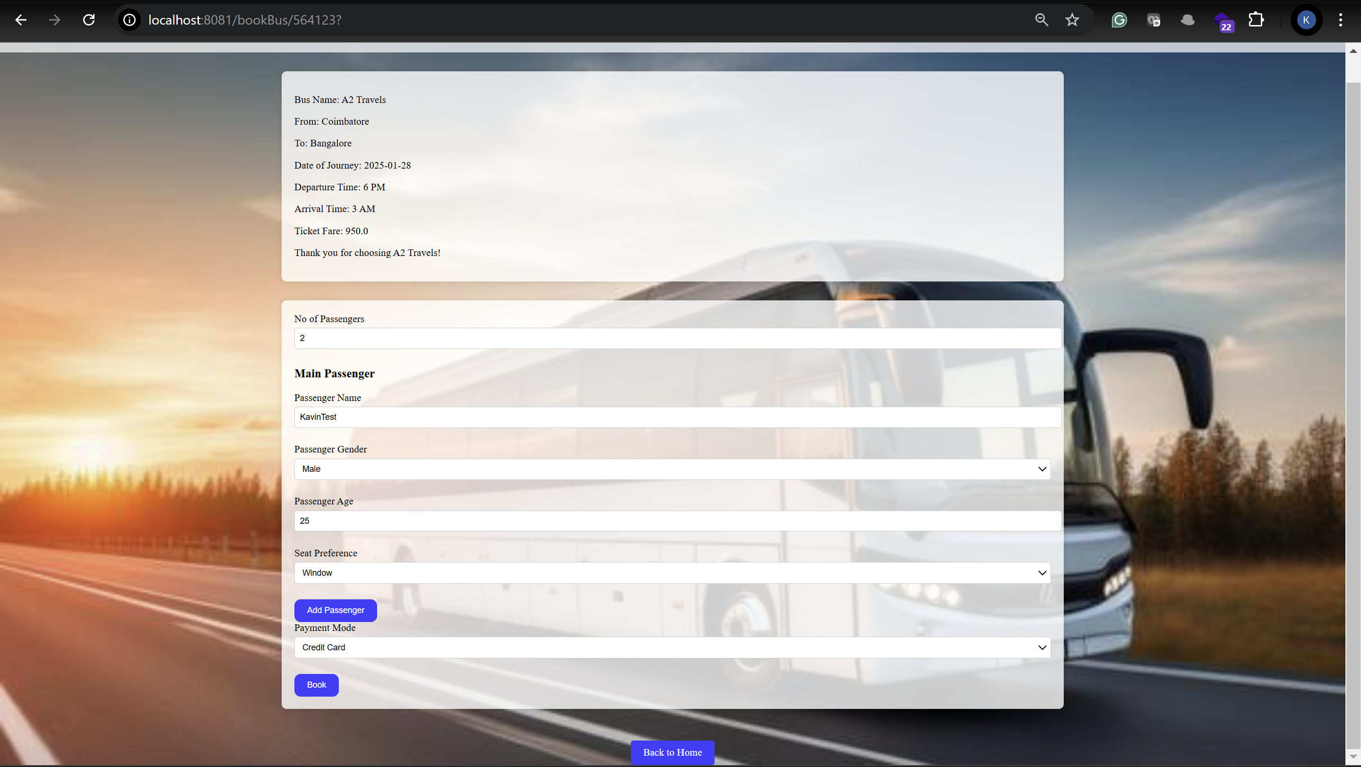

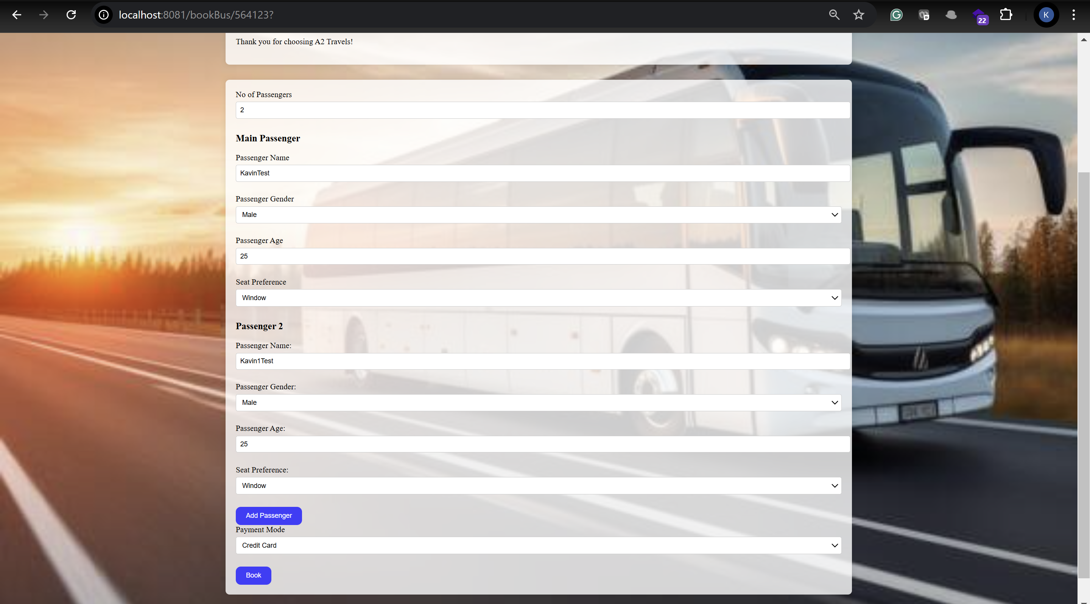

Next, you have to choose the payment method below

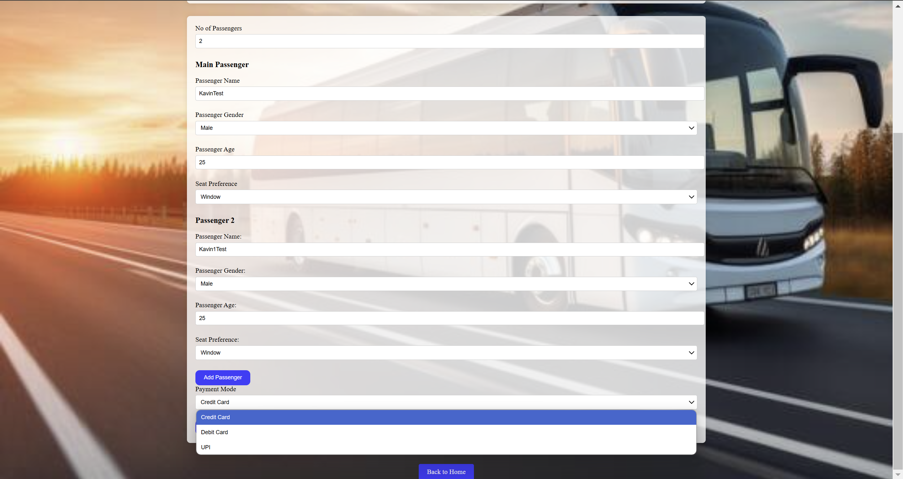

I choose credit card then click on book

Once you book the ticket you will see the confirmation and there is an option to view the ticket in pdf format

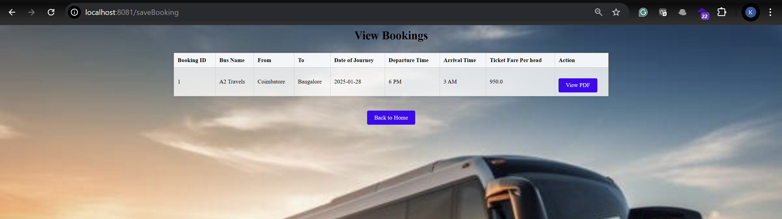

PDF will be downloaded and you can see the ticket as below  
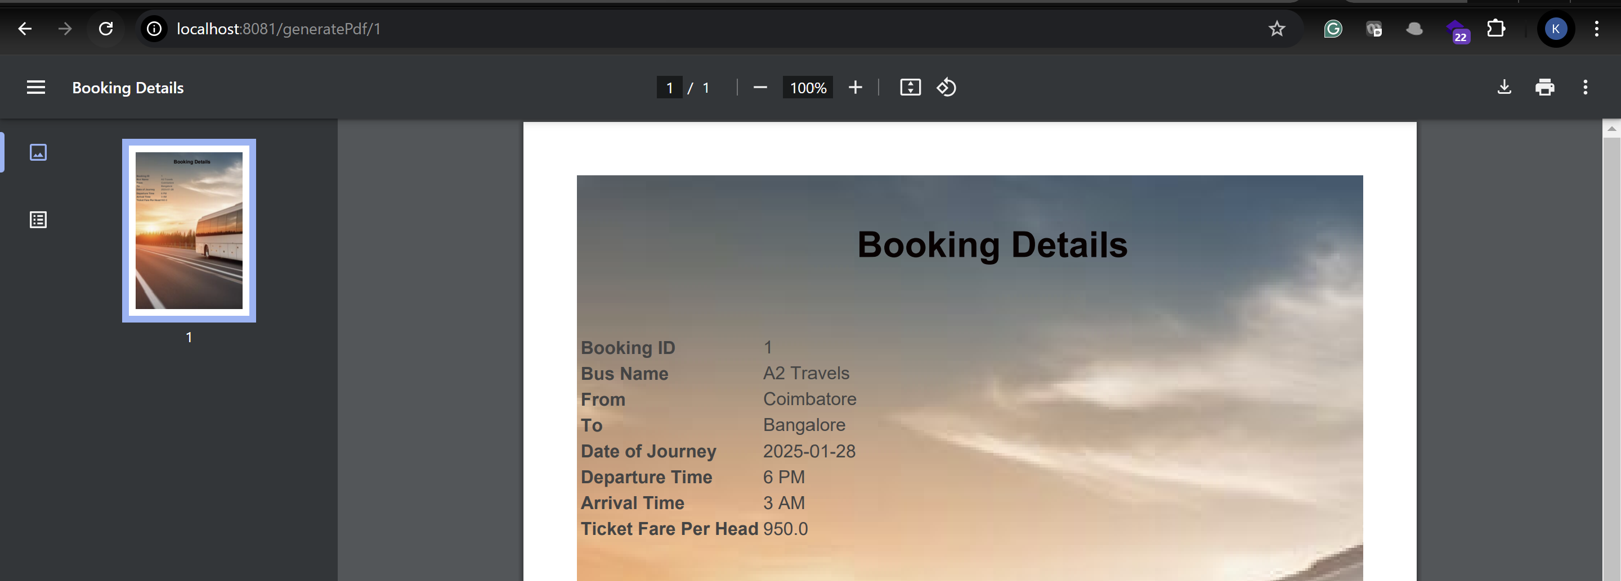

**Swagger API Documentation for BookingController**

**1. Find Respective Buses**

* **Endpoint**: GET /passengerHome
* **Description**: Finds buses based on origin, destination, and travel date.
* **Parameters**:
  + from (required, query parameter): The origin of the journey (e.g., "New York").
  + to (required, query parameter): The destination of the journey (e.g., "Boston").
  + date (required, query parameter): The date of travel (in ISO format: YYYY-MM-DD).
* **Responses**:
  + 200 OK: Returns the list of buses matching the search criteria.
  + 404 Not Found: No buses found for the given parameters.

**2. Book Bus by Bus ID**

* **Endpoint**: GET /bookBus/{busId}
* **Description**: Allows a user to select a bus for booking by its bus ID.
* **Parameters**:
  + busId (required, path parameter): The ID of the bus to be booked.
* **Responses**:
  + 200 OK: Displays the booking page with the selected bus details.

**3. Save Booking**

* **Endpoint**: POST /saveBooking
* **Description**: Saves a booking with passenger details.
* **Parameters** (all required):
  + busId (form parameter): The ID of the bus to be booked.
  + passengerId (form parameter): The ID of the passenger booking the bus.
  + noOfPassengers (form parameter): The number of passengers for this booking.
  + travelPassengerNames (form parameter, list): The names of the passengers.
  + travelPassengerGenders (form parameter, list): The genders of the passengers.
  + travelPassengerAges (form parameter, list): The ages of the passengers.
  + seatPreferences (form parameter, list): The seat preferences for the passengers.
  + paymentMode (form parameter): The payment mode (e.g., "Credit Card").
* **Responses**:
  + 200 OK: Booking saved successfully and redirects to the booking view page.

**4. Get Bookings for Logged-in Passenger**

* **Endpoint**: GET /bookings
* **Description**: Displays the bookings for the currently logged-in passenger.
* **Responses**:
  + 200 OK: Returns the list of bookings for the logged-in user.
  + 404 Not Found: No bookings found for the logged-in passenger.

**5. Generate PDF Booking Confirmation**

* **Endpoint**: GET /generatePdf/{bookingId}
* **Description**: Generates a PDF for the booking confirmation.
* **Parameters**:
  + bookingId (required, path parameter): The ID of the booking for which the PDF is generated.
* **Responses**:
  + 200 OK: Returns the booking confirmation PDF.
  + 404 Not Found: Booking not found with the provided ID.

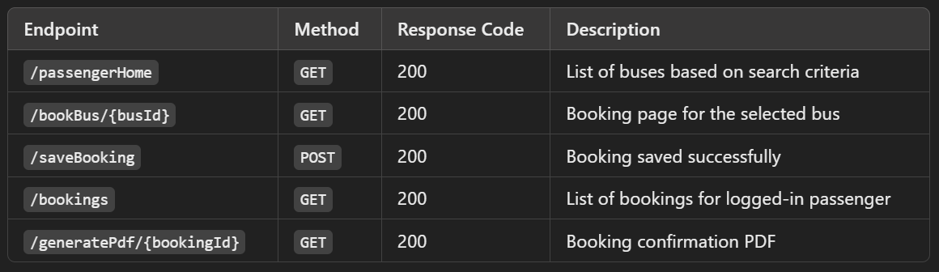

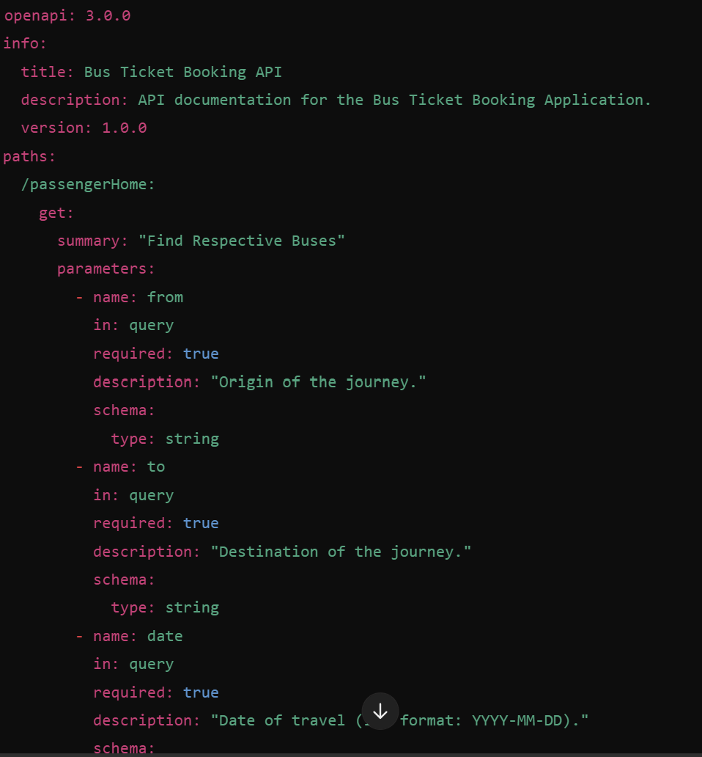

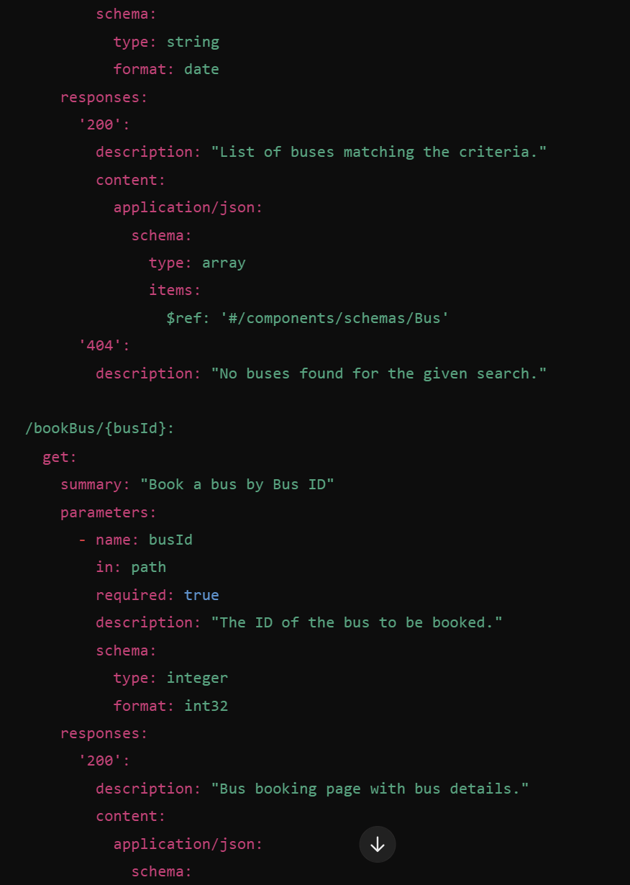

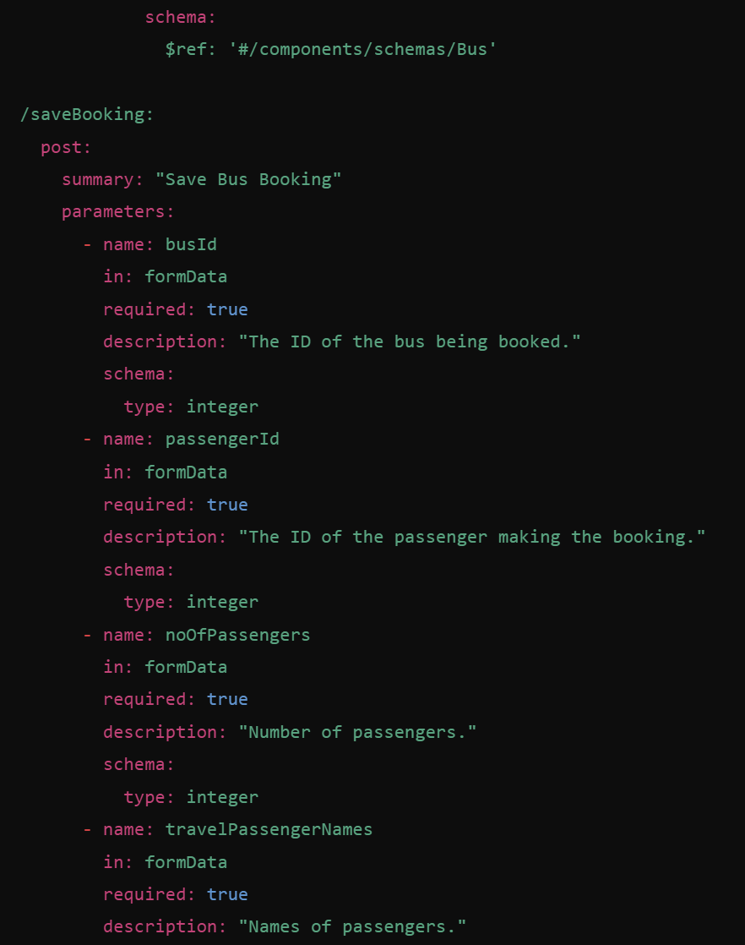

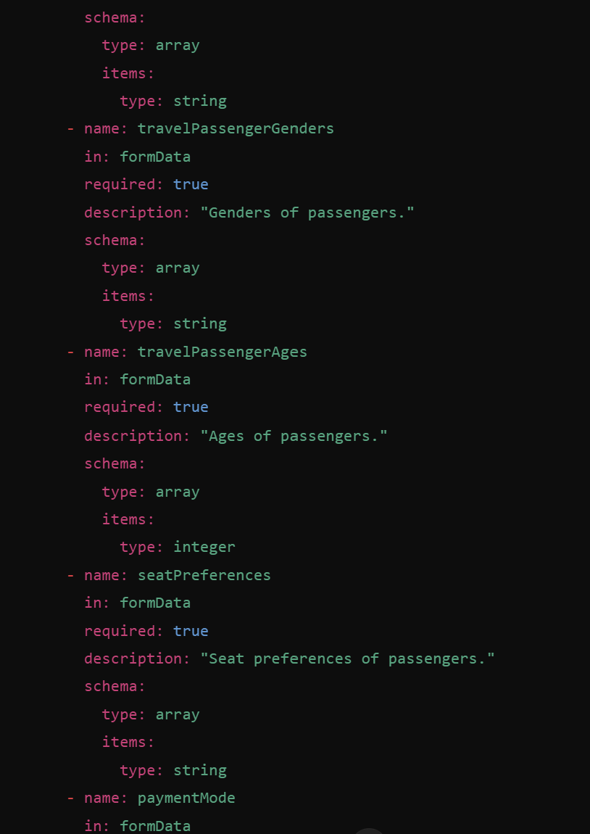

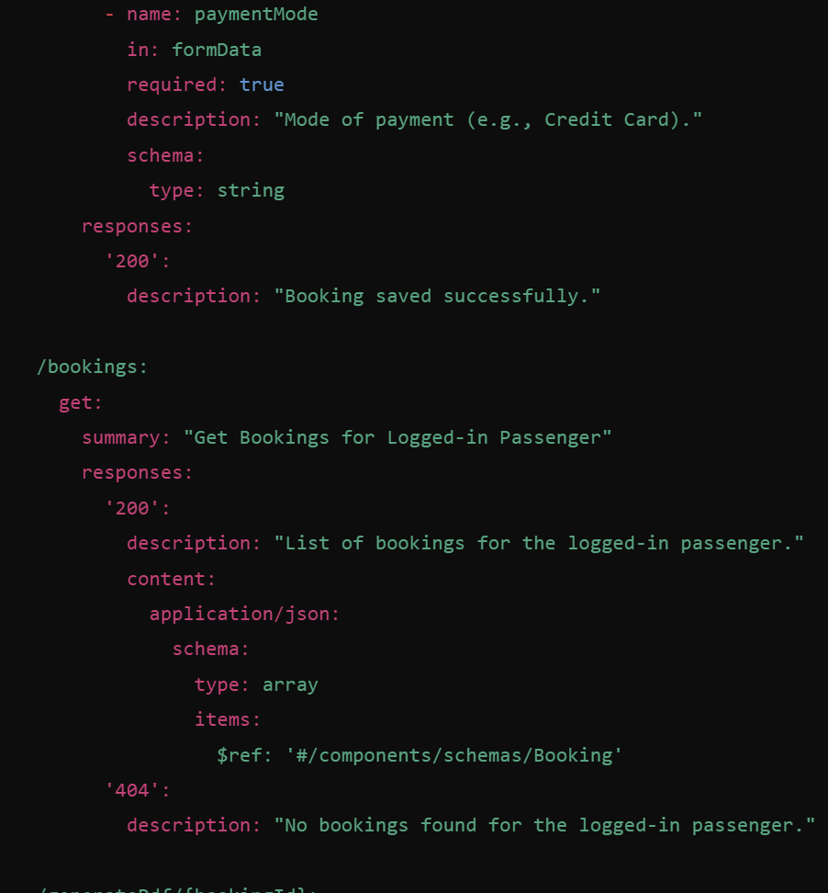

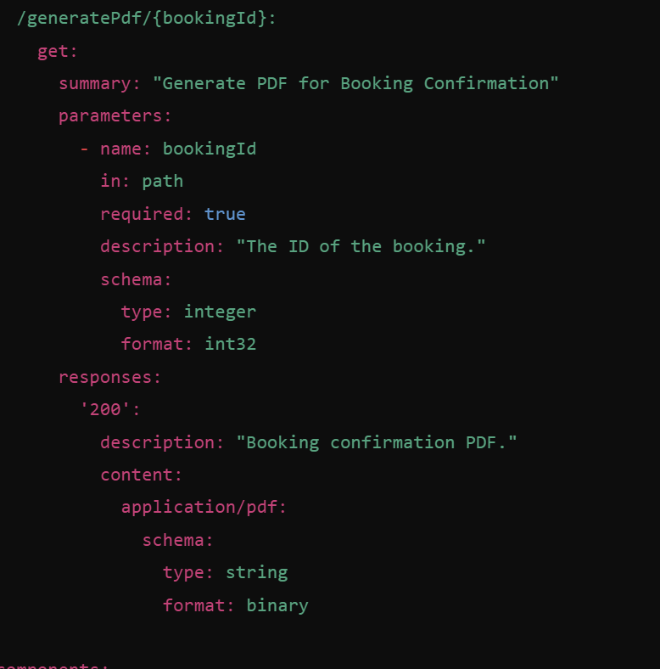

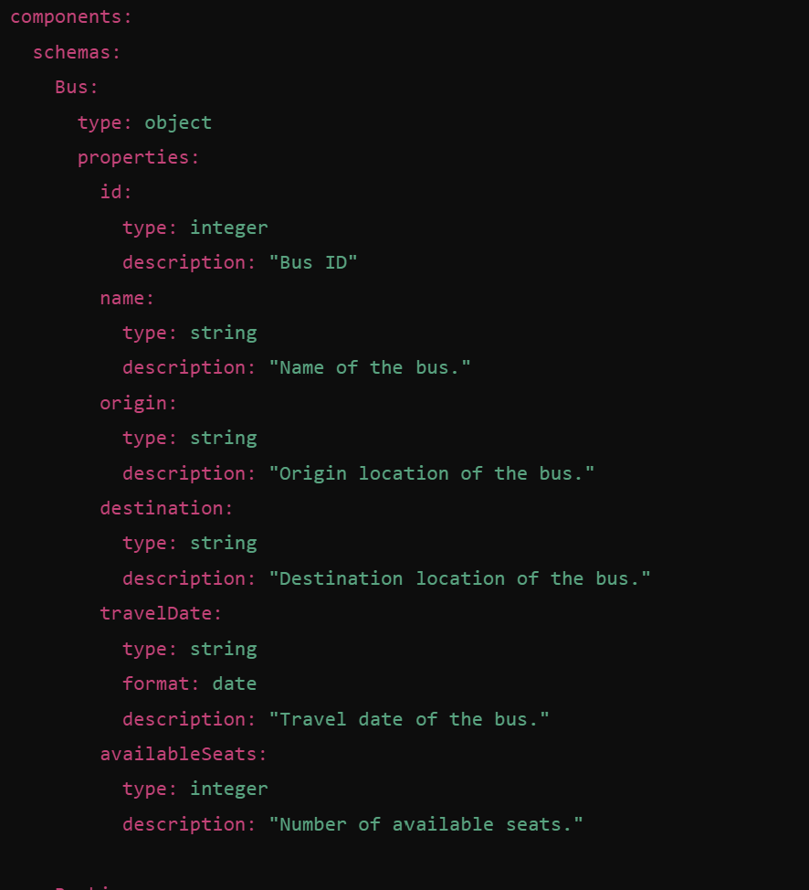

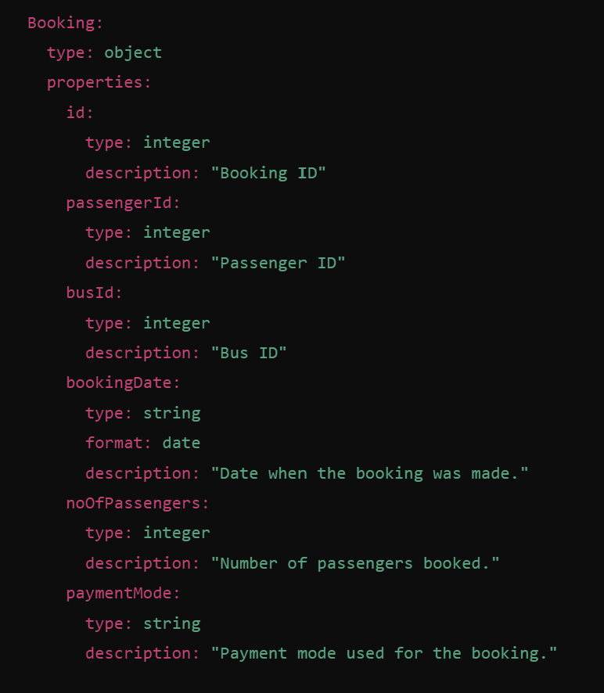

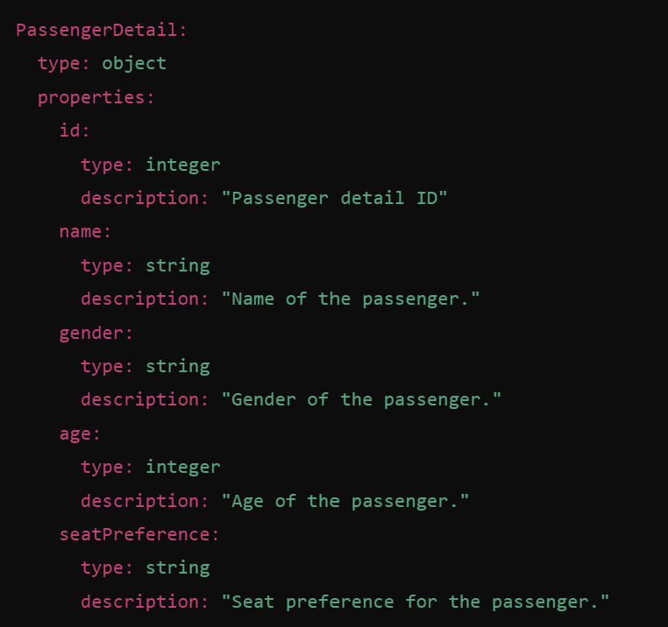

**Swagger API Documentation for BusController**

**1. Get Admin Page**

* **Endpoint**: GET /admin
* **Description**: Displays the admin page, which is accessible only to users with admin privileges.
* **Responses**:
  + 200 OK: Returns the admin page for the logged-in admin.

**2. Show Bus Registration Form**

* **Endpoint**: GET /addBus
* **Description**: Displays the form to add a new bus to the system.
* **Responses**:
  + 200 OK: Returns the page with the bus registration form.

**3. Save Bus**

* **Endpoint**: POST /saveBus
* **Description**: Saves a new bus to the database.
* **Parameters**:
  + bus (required, body): A Bus object containing bus details (e.g., bus number, origin, destination).
* **Responses**:
  + 200 OK: Successfully saves the bus and redirects to the admin page.
  + 400 Bad Request: Invalid bus details.

**4. View All Buses**

* **Endpoint**: GET /viewAllBuses
* **Description**: Displays all the buses in the system.
* **Responses**:
  + 200 OK: Returns a list of all buses.
  + 404 Not Found: No buses found in the system.

**5. Show Search Form for Bus by Bus ID**

* **Endpoint**: GET /findBusById
* **Description**: Displays the form to search for a bus by its ID.
* **Responses**:
  + 200 OK: Returns the page with the search form for bus ID.

**6. Find Bus by ID**

* **Endpoint**: GET /findBusId
* **Description**: Searches for a bus by its ID.
* **Parameters**:
  + busId (required, query parameter): The ID of the bus to be searched.
* **Responses**:
  + 200 OK: Returns the bus details if found.
  + 404 Not Found: Returns an error message if the bus is not found.

**7. Show Bus Update Form**

* **Endpoint**: GET /updateByBus
* **Description**: Displays the form to update bus details.
* **Parameters**:
  + busId (required, query parameter): The ID of the bus to be updated.
* **Responses**:
  + 200 OK: Displays the update form with existing bus details.
  + 404 Not Found: Returns an error message if the bus with the given ID is not found.

**8. Update Bus Details**

* **Endpoint**: PUT /saveUpdateBus
* **Description**: Updates the details of an existing bus.
* **Parameters**:
  + bus (required, body): The updated Bus object with new details.
* **Responses**:
  + 200 OK: Successfully updates the bus and redirects to the view buses page.
  + 400 Bad Request: Invalid bus details.
  + 404 Not Found: Returns an error if the bus with the given ID is not found.

**9. Delete Bus**

* **Endpoint**: DELETE /delete/{serialNo}
* **Description**: Deletes a bus from the system based on the provided bus serial number.
* **Parameters**:
  + serialNo (required, path parameter): The serial number of the bus to be deleted.
* **Responses**:
  + 200 OK: Successfully deletes the bus and shows a success message.
  + 404 Not Found: Returns an error message if the bus with the given serial number is not found.

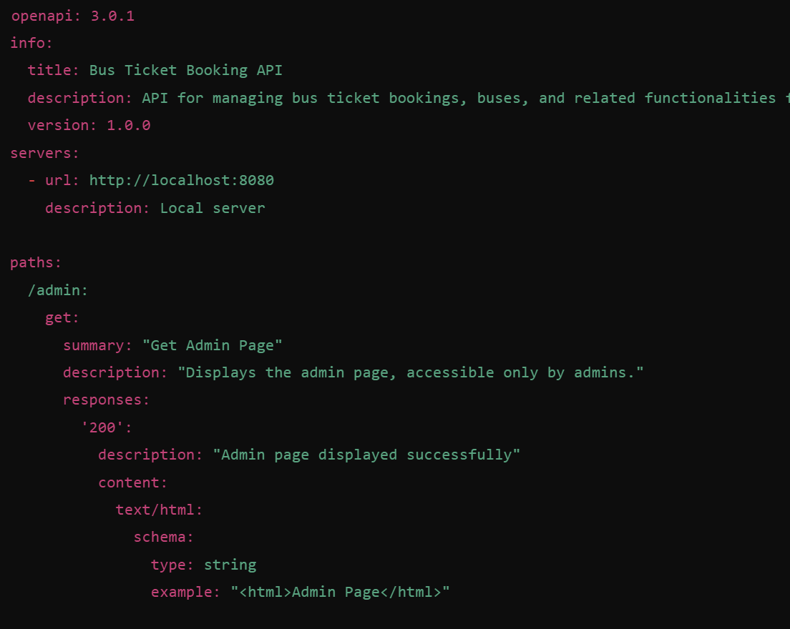

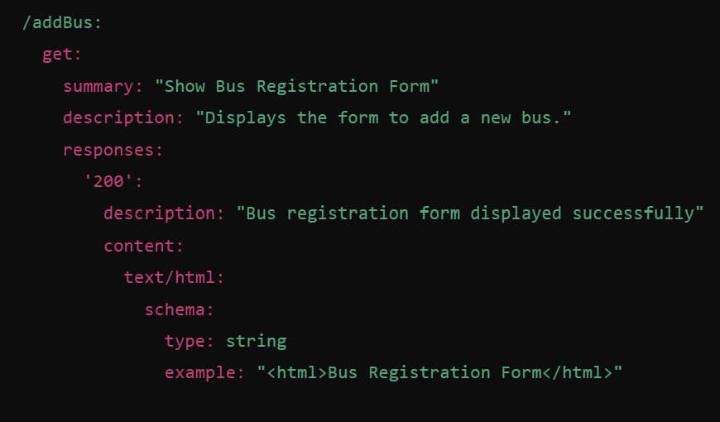

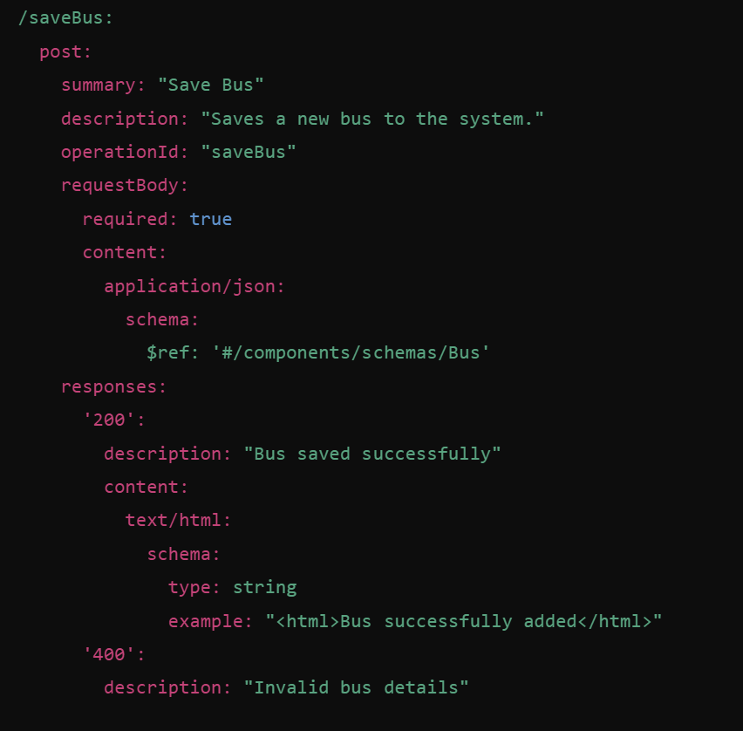

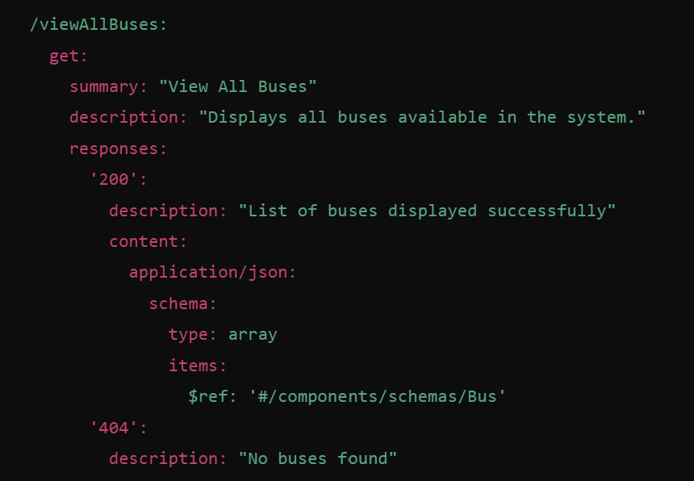

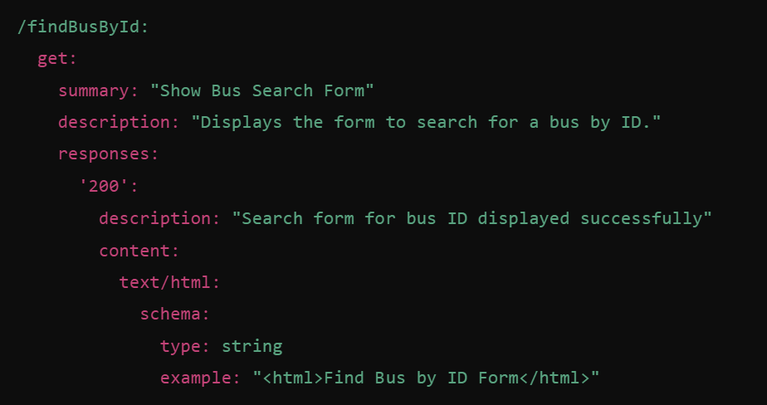

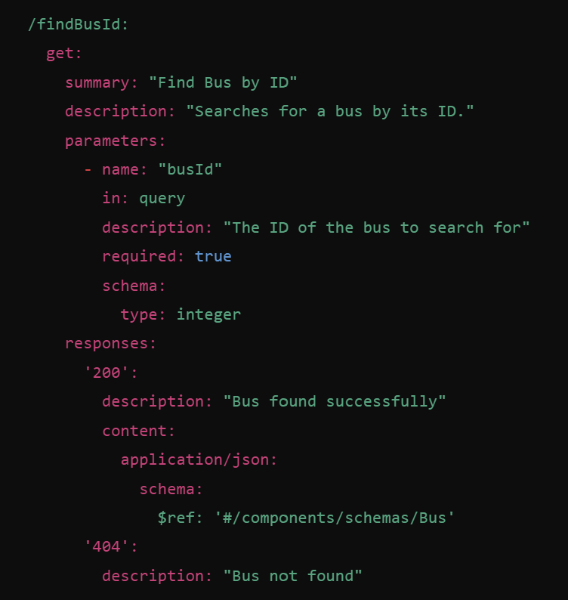

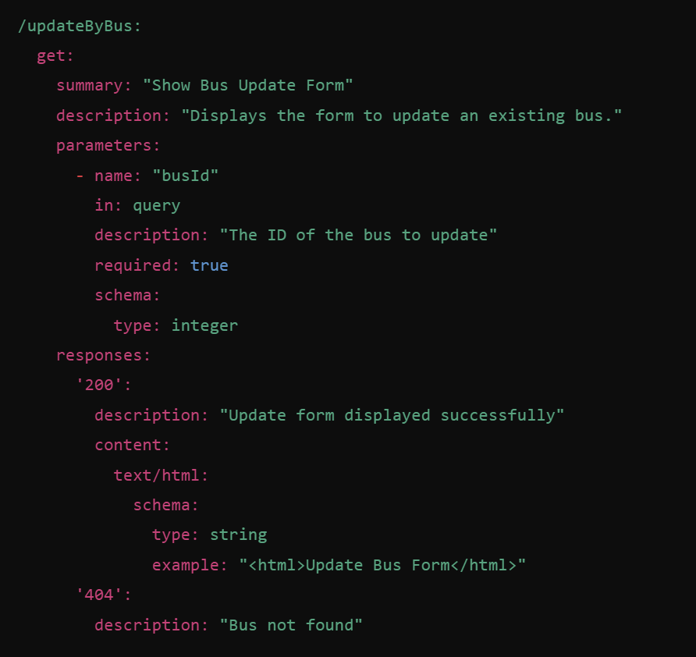

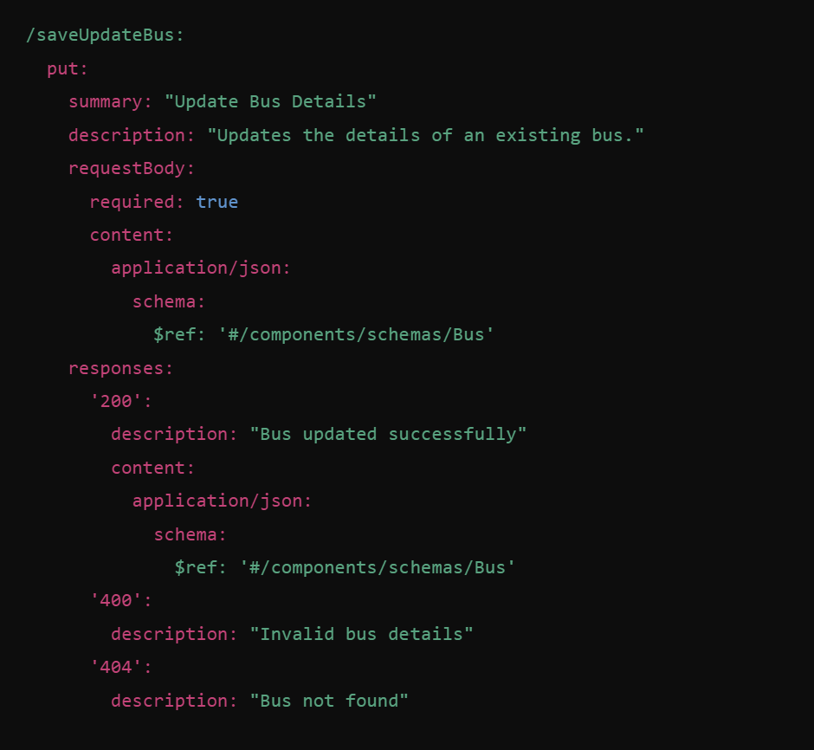

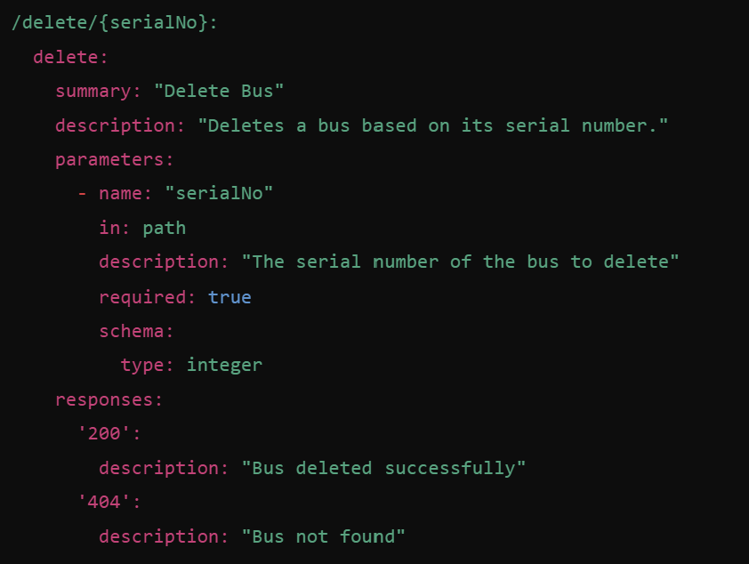

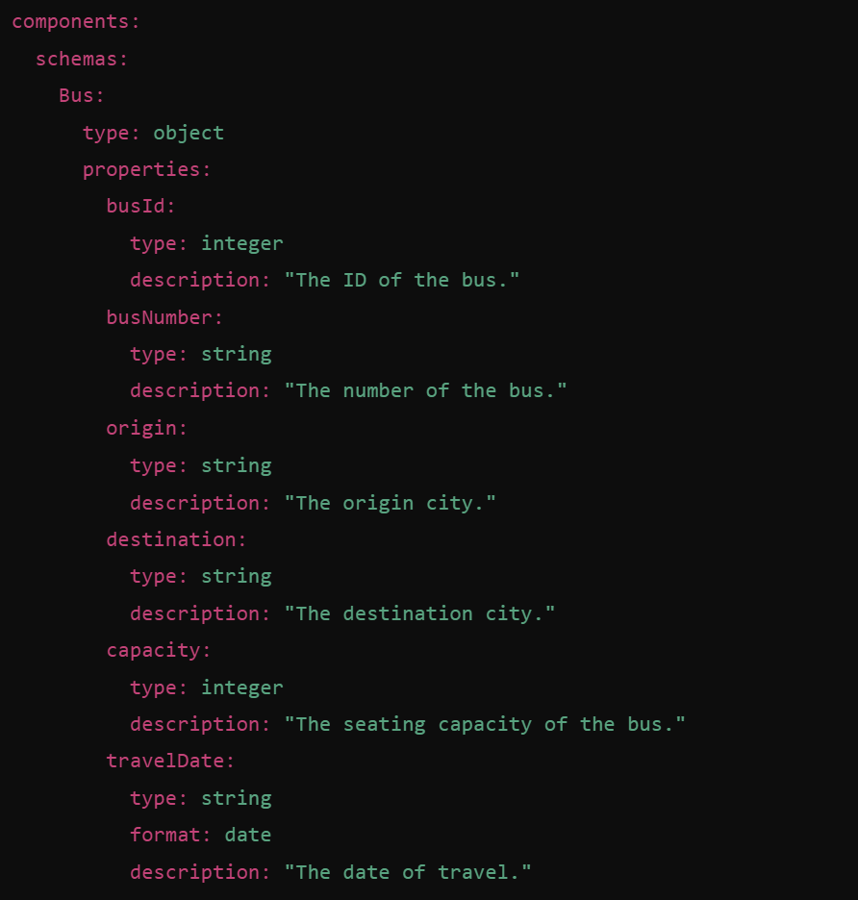

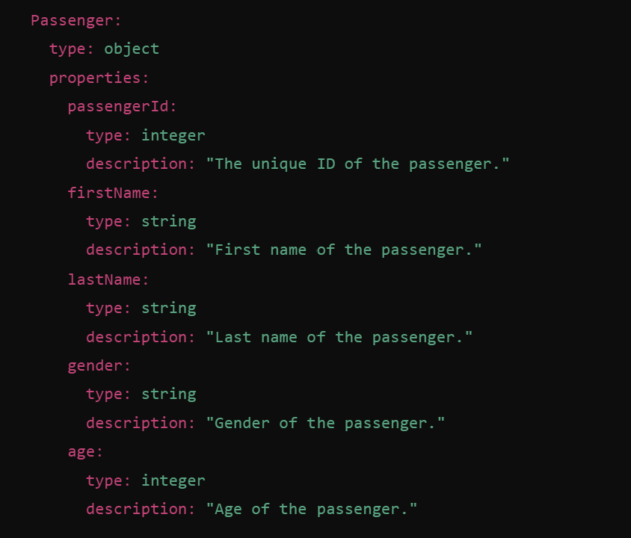

**Swagger API Documentation for PassengerController**

**1. Show Registration Form**

* **Endpoint**: GET /registration
* **Description**: Displays the user registration form.
* **Parameters**: None
* **Responses**:
  + 200 OK: Returns the registration page with the form.

**2. Save Passenger (Register New User)**

* **Endpoint**: POST /registration
* **Description**: Saves the passenger registration details.
* **Parameters**:
  + userDto (required, form parameter): The user registration details including:
    - username: The desired username for the user.
    - password: The password for the new user.
    - email: The email address of the user.
    - role: The role of the user (always set as "USER").
* **Responses**:
  + 200 OK: Registration successful. A success message is displayed.
  + 400 Bad Request: Invalid or missing data for user registration.

**3. Login Page**

* **Endpoint**: GET /login
* **Description**: Displays the login page.
* **Parameters**: None
* **Responses**:
  + 200 OK: Returns the login page.

**4. User Home Page**

* **Endpoint**: GET /user
* **Description**: Displays the user home page for the logged-in passenger, including their details.
* **Parameters**:
  + principal: The currently logged-in user (automatically provided by Spring Security).
* **Responses**:
  + 200 OK: Returns the user's home page with the passenger's details.

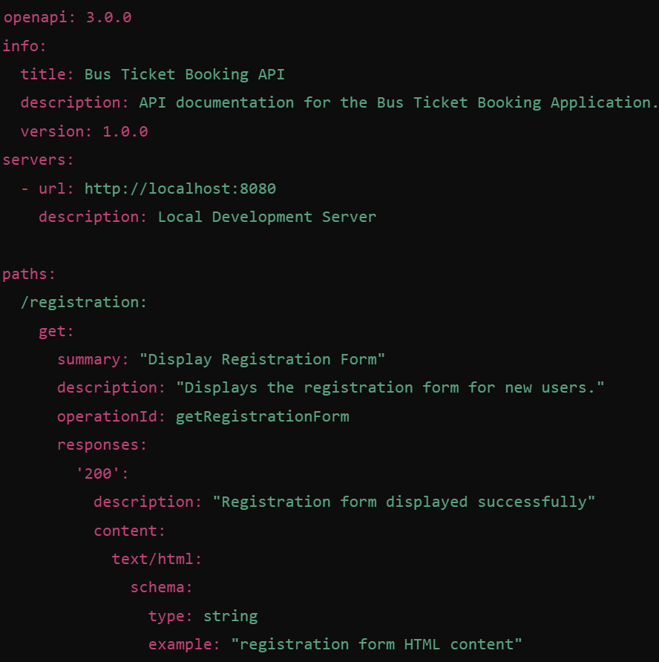

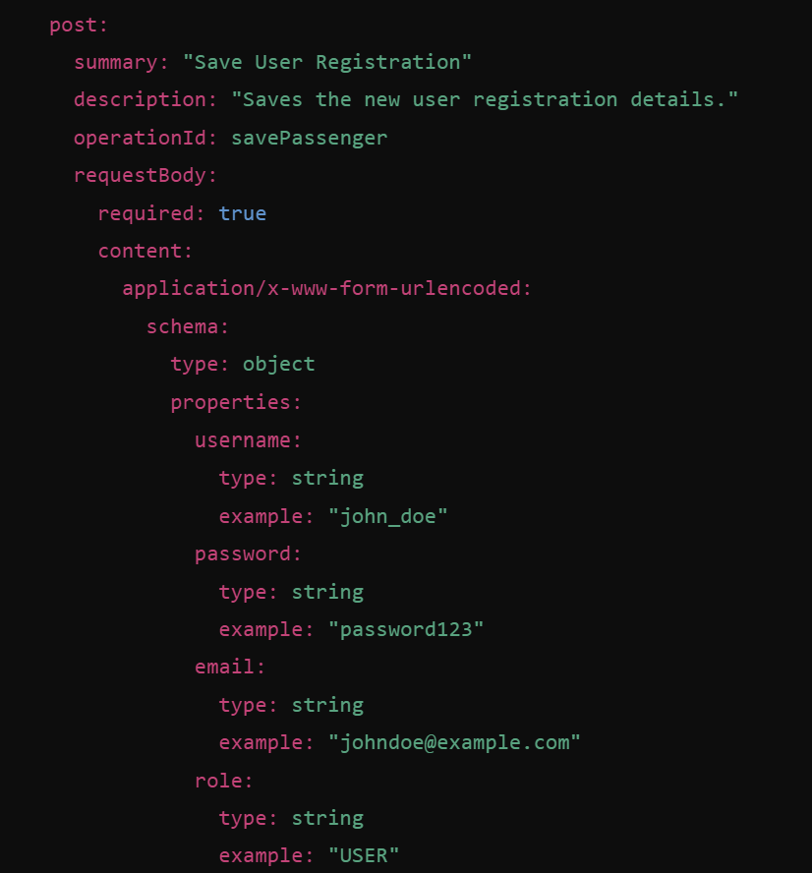

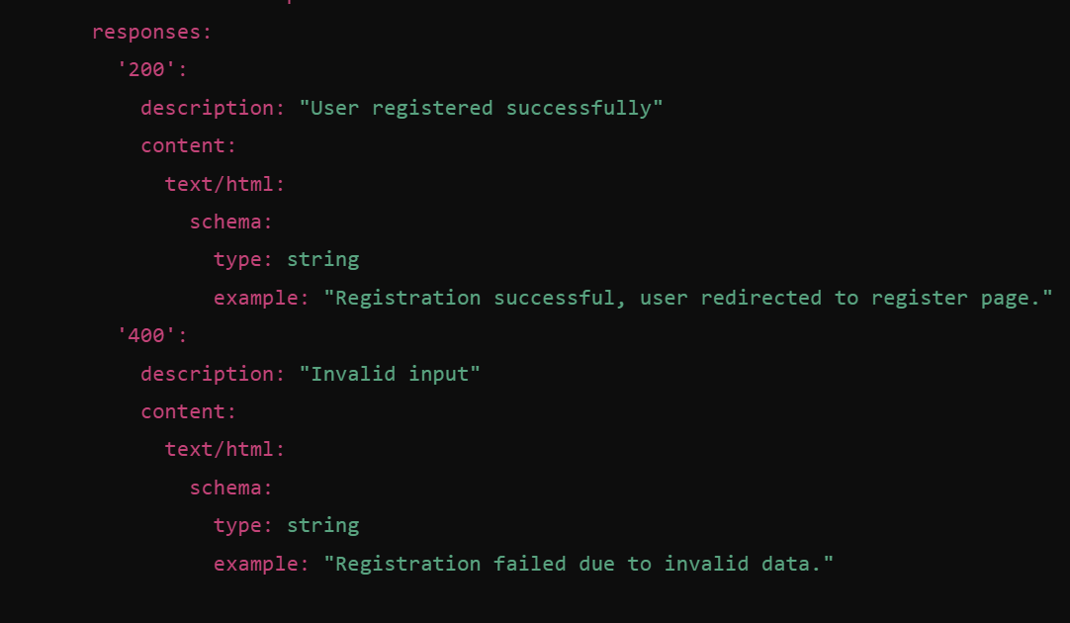

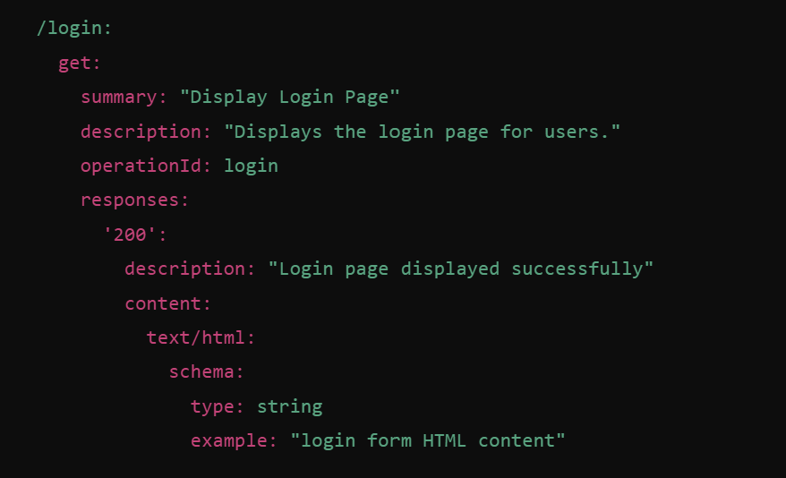

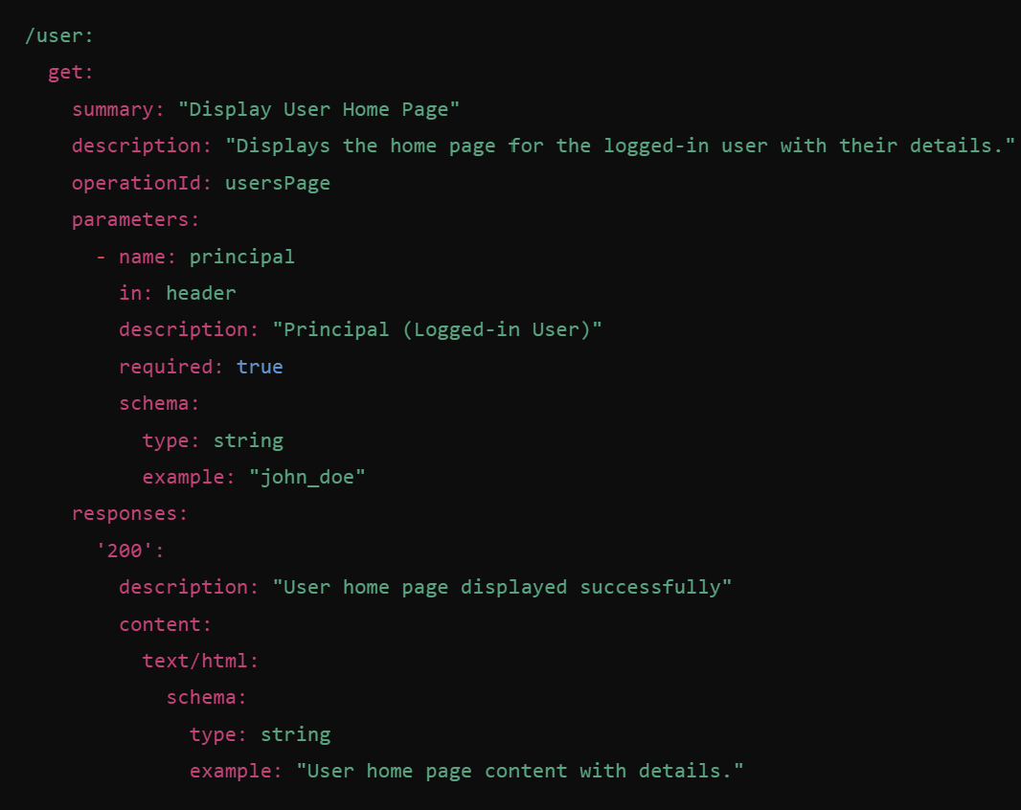

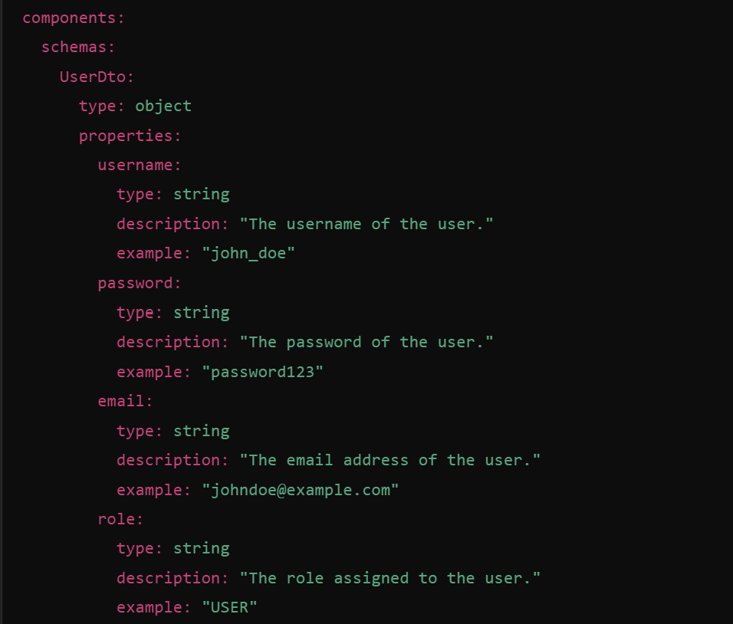

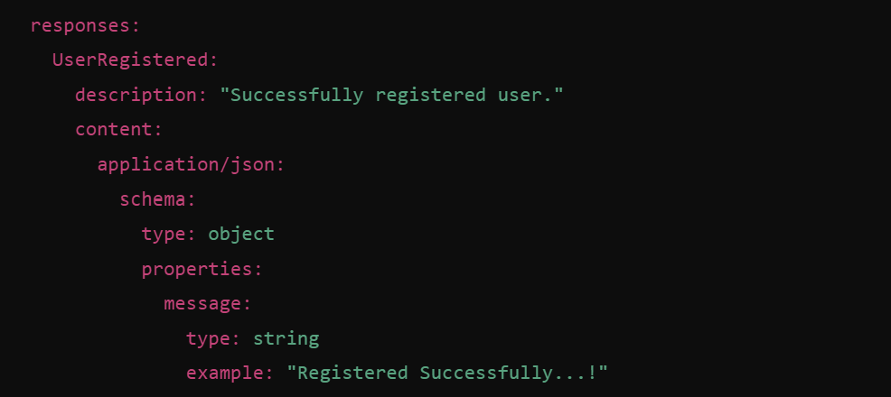

**Schema Structure**

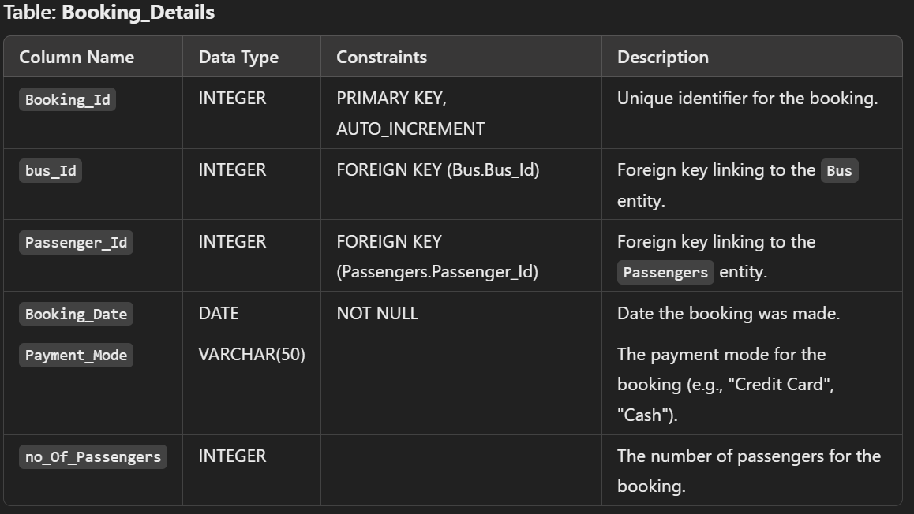

**Foreign Key Relationships:**

* **Bus Table**:
  + bus_Id is a foreign key referencing Bus(bus_Id).
* **Passengers Table**:
  + Passenger_Id is a foreign key referencing Passengers(Passenger_Id).

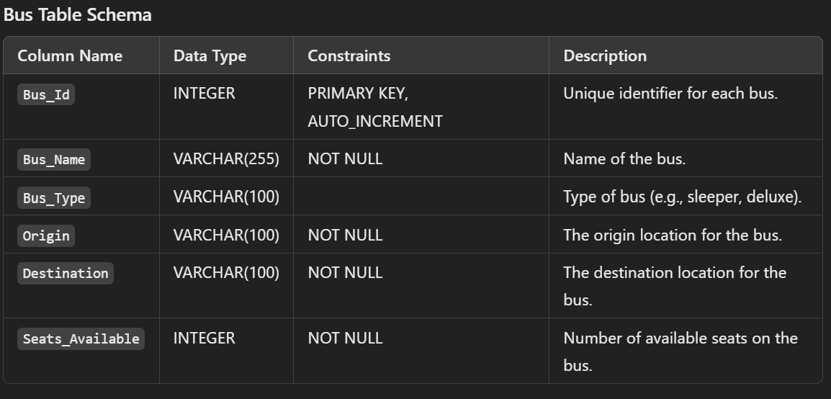

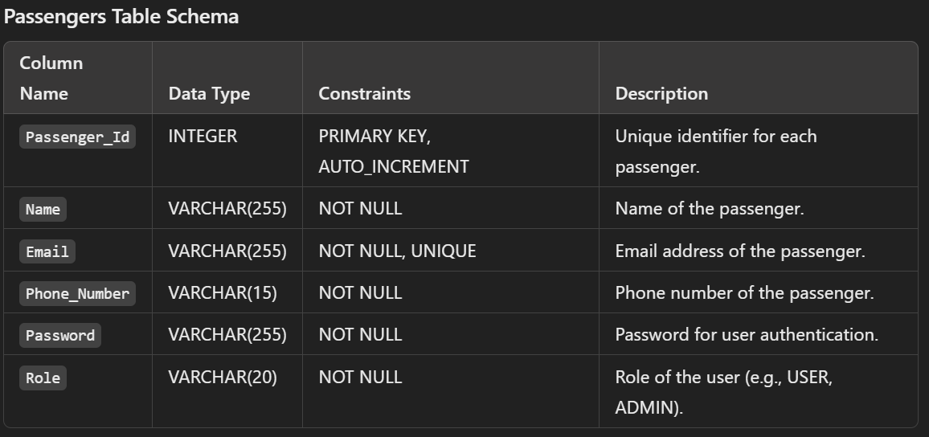

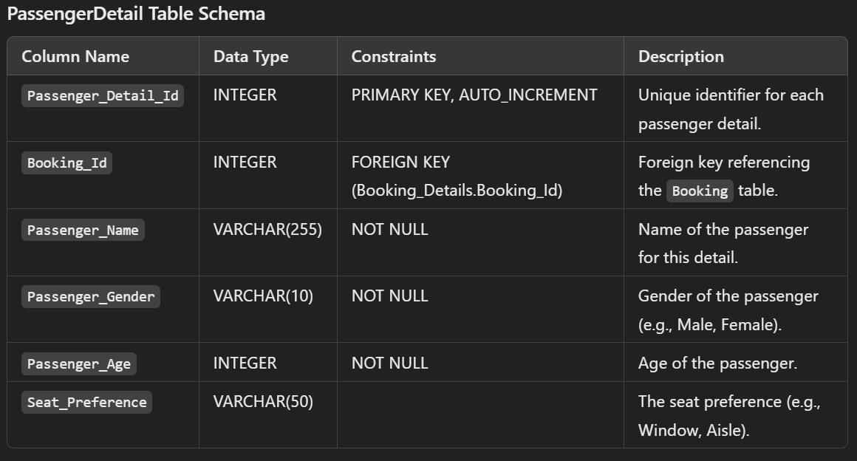

**ERD (Entity Relationship Diagram)**

Here’s the relationship breakdown between the Booking model and its associated tables:

* **Booking ↔ Bus**: Many-to-One relationship. A booking is related to a single bus.
* **Booking ↔ Passengers**: Many-to-One relationship. A booking is related to a single passenger.
* **Booking ↔ PassengerDetail**: One-to-Many relationship. A booking can have multiple passenger details.

**ERD Overview:**

* **Booking** has foreign keys to both **Bus** and **Passengers**.
* **Booking** has a one-to-many relationship with **PassengerDetail**.

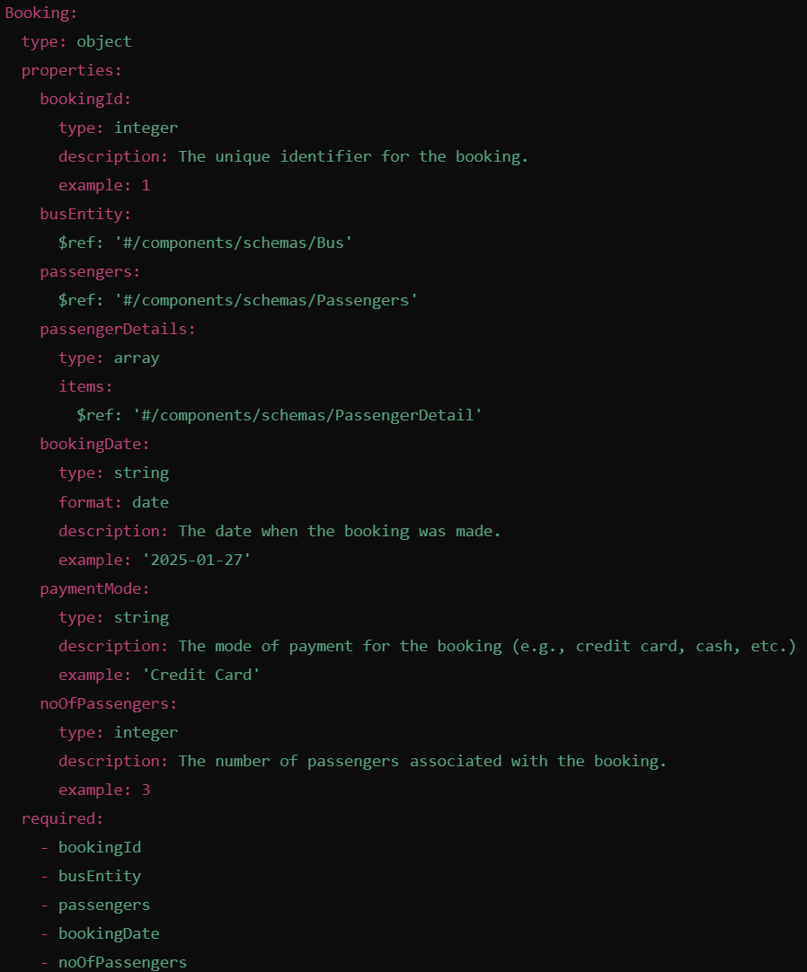

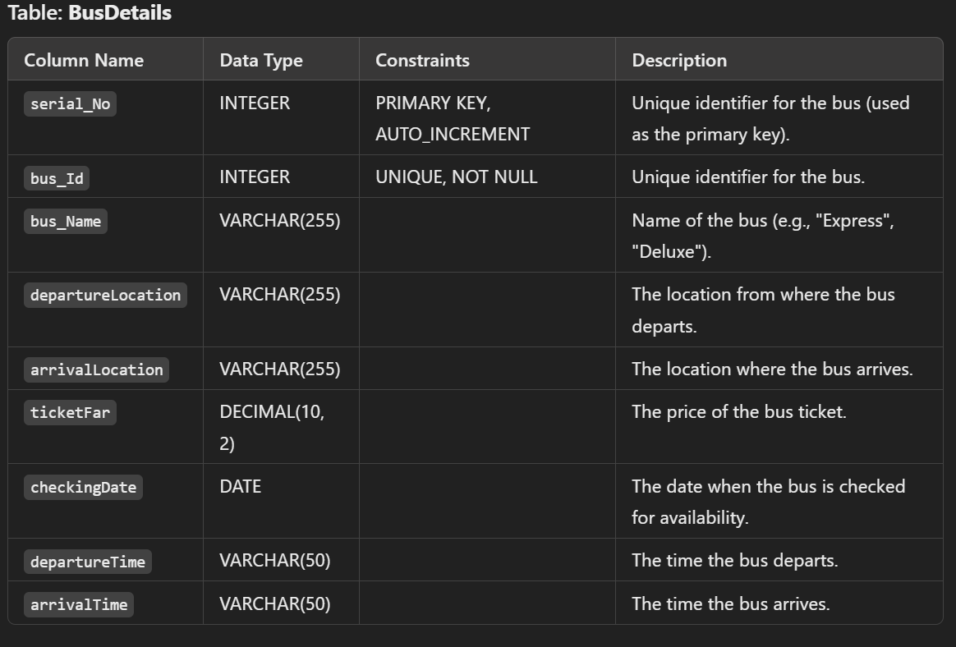

**ERD (Entity Relationship Diagram)**

* **Bus** is an entity that represents bus details.
* It is related to **Booking** through the bus_Id as a foreign key in the Booking_Details table.
* Each **Bus** can have many bookings associated with it, but a **Booking** belongs to only one bus.

**Booking Table Schema**

* **Bus Table**:
  + bus_Id is a foreign key in Booking_Details, referencing Bus(bus_Id).

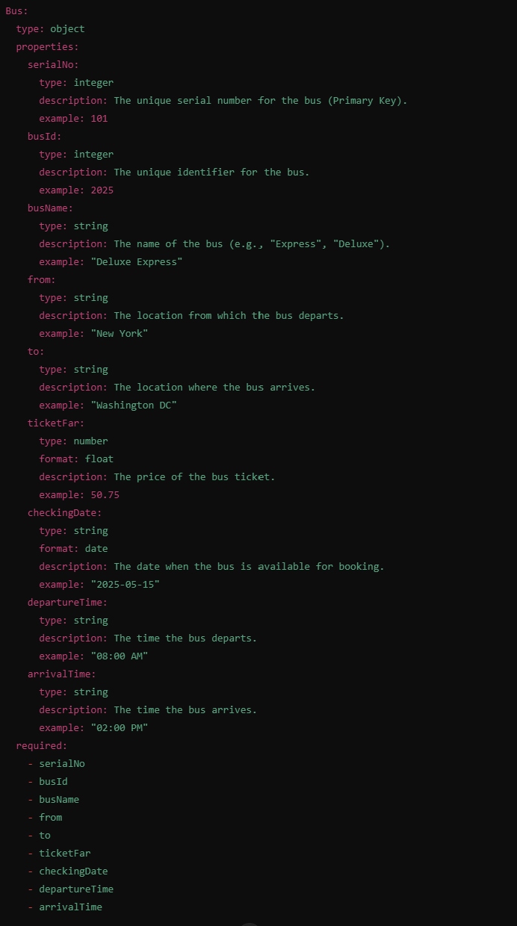

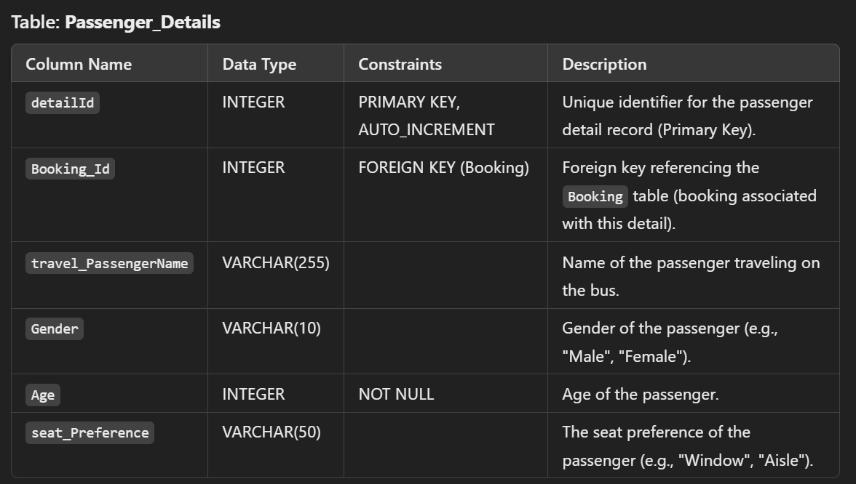

**ERD (Entity Relationship Diagram)**

* **PassengerDetail** is an entity that represents detailed information about individual passengers in a booking.
* It has a **Many-to-One** relationship with the **Booking** model, where multiple passenger details can belong to one booking.

**Relationships:**

* **PassengerDetail** ↔ **Booking**
  + Each **Booking** can have multiple **PassengerDetails**, while each **PassengerDetail** belongs to one **Booking**.

**Booking Table Schema**

* **Booking Table**:
  + Booking_Id is referenced as a foreign key in the Passenger_Details table.

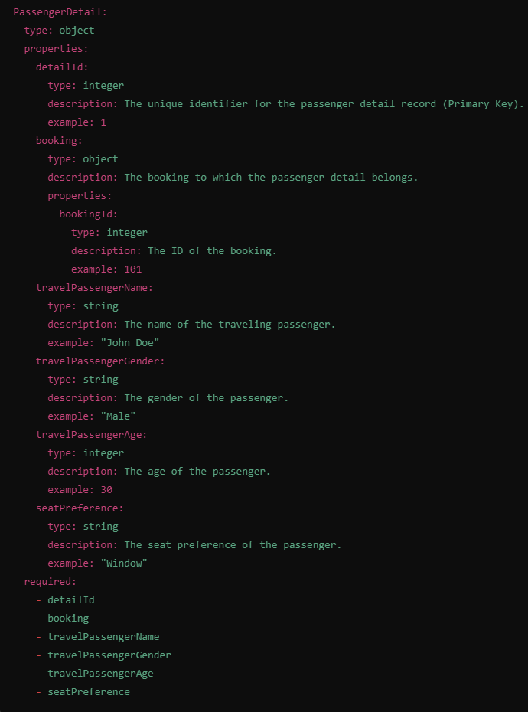

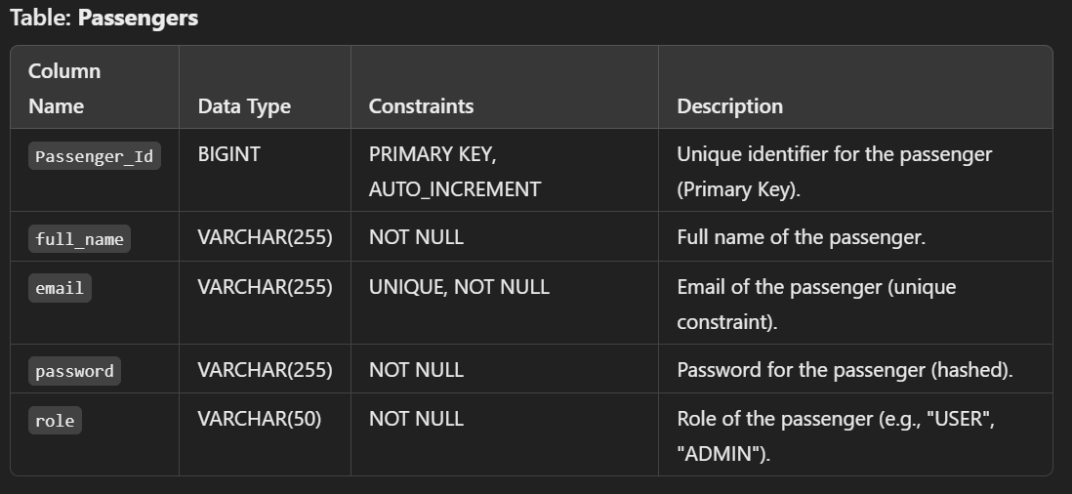

**ERD (Entity Relationship Diagram)**

* **Passengers** is an entity that stores the details of the passengers.
* It has a **One-to-Many** relationship with the **Booking** model (each passenger can have multiple bookings).

**Relationships:**

* **Passengers** ↔ **Booking**
  + A passenger can have multiple bookings. Each booking is linked to a passenger.

